Lesson 5
Objective: Name decimal fractions in expanded, unit, and word forms by applying place value reasoning.

Suggested Lesson Structure
 Fluency Practice (12 minutes)
 Application Problem (8 minutes)
 Concept Development (30 minutes)
 Student Debrief (10 minutes)
Total Time (60 minutes)
Fluency Practice (12 minutes)
- Sprint: Multiply Decimals by 10, 100, and 1000 5.NBT.2 (8 minutes)
- Multiply and Divide by Exponents 5.NBT.2 (2 minutes)
- Multiply Metric Units 5.MD.1 (2 minutes)
Sprint: Multiply Decimals by 10, 100, and 1000 (8 minutes)
Materials: (S) Multiply Decimals by 10, 100, and 1000 Sprint
Note: This Sprint helps students work towards automaticity of multiplying and dividing decimals by 10, 100, and 1000.
Multiply and Divide by Exponents (2 minutes)
Materials: (S) Millions to thousandths place value chart (Lesson 1 Template), personal white board
Note: This fluency activity helps students work towards mastery of the concept introduced in Lesson 4.
Depending on students’ depth of knowledge, this activity may be done with support from a personal place value chart or done simply by responding on the personal white board with the product or quotient.
T: (Project place value chart from millions to thousandths.) Write 54 tenths as a decimal.
S: (Write 5 in the ones column and 4 in the tenths column.)
T: Say the decimal.
S: 5.4 (five and four tenths).
T: Multiply it by 10².
S: (Indicate change in value by using arrows from each original place value to the product on their personal white boards. Or, instead, simply write product.)
T: Say the product.
S: 540.
Repeat the process and sequence for 0.6 × 10², 0.6 ÷ 10², 2.784 × 10³, and 6583 ÷ 10³.
Multiplying Metric Units (2 minutes)
Materials: (S) Millions to thousandths place value chart (Lesson 1 Template), personal white board
Note: This fluency activity helps students work towards mastery of the concept introduced in Lesson 4.
T: (Write 3 m = ___ cm.) Show 3 on your place value chart.
S: (Write 3 in the ones column.)
T: How many centimeters are in 1 meter?
S: 100 centimeters.
T: Show how many centimeters are in 3 meters on your place value chart.
S: (Cross out the 3 and shift it two place values to the left to show 300.)
T: How many centimeters are in 3 meters?
S: 300 centimeters.
Repeat the process and procedure for 7 kg = ____ g, 7000 mL = ____ L, 7500 m = ____ km ____ m, and
8350 g = ____ kg ____ g.
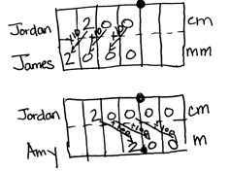
Application Problem (8 minutes)
Jordan measures a desk at 200 cm. James measures the same desk in millimeters, and Amy measures the same desk in meters. What is James’ measurement in millimeters? What is Amy’s measurement in meters? Show your thinking using a place value chart or an equation with exponents.
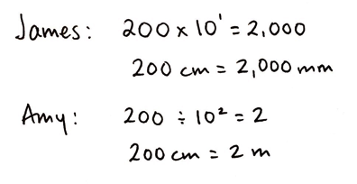
Note: Today’s Application Problem offers students a quick review of yesterday’s concepts before moving forward to naming decimals.
Concept Development (30 minutes)
Materials: (S) Personal white board, thousands through thousandths place value chart (Template)
Opener
T: (Write three thousand forty-seven on the board.) On your personal board, write this number in standard form, expanded form, and unit form.
T: Explain to your partner the purpose of writing this number in these different forms.
S: Standard form shows us the digits that we are using to represent that amount. Expanded form shows how much each digit is worth and that the number is a total of those values added together. Unit form helps us see how many of each size unit are in the number.
Problem 1
Represent 1 thousandth and 3 thousandths in standard, expanded, and unit form.
T: Write 1 thousandth using digits on your place value chart.
T: How many ones, tenths, hundredths, thousandths?
S: Zero. Zero. Zero. One.
T: This is the standard form of the decimal for 1 thousandth.
T: We write 1 thousandth as a fraction like this: $\frac{1}{1000}$. (Write $\frac{1}{1000}$ on the board.)
T: 1 thousandth is a single copy of a thousandth. We write the expanded form using a fraction like this: 1 $×$ $\left(\frac{1}{1000}\right)$. (Write 1 $×\frac{1}{1000}$ on the board, and say 1 copy of 1 thousandth.) And, we write the expanded form using a decimal like this: 1 $×$ 0.001. (Write 1 $×$ 0.001 on the board.)
T: We write the unit form of 1 thousandth like this: 1 thousandth. (Write on the board.) We write a numeral (point to 1) and the unit name (point to thousandth) as a word.
One thousandth = 0.001 = $\frac{1}{1000}$
$\frac{1}{1000}$ = 1 × $\left(\frac{1}{1000}\right)$
0.001 = 1 × 0.001
1 thousandth
MP.7
T: Imagine 3 copies of 1 thousandth. How many thousandths is that?
S: 3 thousandths.
T: (Write in standard form and as a fraction.)
T: 3 thousandths is 3 copies of 1 thousandth. Turn and talk to your partner about how this would be written in expanded form using a fraction and using a decimal.
Three thousandths = 0.003 = $\frac{3}{1000}$
$\frac{3}{1000}$ = 3 × $\left(\frac{1}{1000}\right)$
0.003 = 3 × 0.001
3 thousandths

Problem 2

NOTES ON
MULTIPLE MEANS
OF ENGAGEMENT:
Students struggling with naming decimals using different unit forms may benefit from a return to concrete materials. Try using place value disks to make trades for smaller units. Also, place value understandings from Lessons 1 and 2 help make the connection between 1 hundredth 3 thousandths and 13 thousandths.
It may also be fruitful to invite students to extend their Grade 4 experiences with finding equivalent fractions for tenths and hundredths to finding equivalent fraction representations in thousandths.

Represent 13 thousandths in standard, expanded, and unit form.
T: Write 13 thousandths in standard form and expanded form using fractions and then using decimals. Turn and share with your partner.
S: Zero point zero one three is standard form. Expanded forms are
1 $×$ $\left(\frac{1}{100}\right)$ + 3 $×$ $\left(\frac{1}{1000}\right)$ and 1 $×$ 0.01 + 3 $×$ 0.001
T: Now, write this decimal in unit form.
S: 1 hundredth 3 thousandths 13 thousandths.
T: (Circulate and write responses on the board.) I notice that there seems to be more than one way to write this decimal in unit form. Why?
S: This is 13 copies of 1 thousandth. You can write the units separately or write the 1 hundredth as 10 thousandths. You add 10 thousandths and 3 thousandths to get 13 thousandths.
Thirteen thousandths = 0.013 = $\frac{13}{1000}$
$\frac{13}{1000}$ = 13 $×$ ($\frac{1}{1000}$)
0.013 = 1 × 0.01 + 3 × 0.001
1 hundredth 3 thousandths
13 thousandths
Repeat with 0.273 and 1.608, allowing students to combine units in their unit forms (e.g., 2 tenths 73 thousandths, 273 thousandths, 27 hundredths 3 thousandths). Use more or fewer examples as needed, reminding students who need it that and indicates the decimal in word form.
Problem 3
Represent 25.413 in word, expanded, and unit form.
T: (Write 25.413 on the board.) Write 25.413 in word form on your board.
S: (Write.) Twenty-five and four hundred thirteen thousandths.
T: Now, write this decimal in unit form on your board.
S: 2 tens 5 ones 4 tenths 1 hundredth 3 thousandths.
T: What are other unit forms of this number?
S: 25 ones 413 thousandths. 254 tenths 13 hundredths. 25,413 thousandths.
T: Write 25.413 as a mixed number, and then in expanded form. Compare your work with your partner’s.
Twenty-five and four hundred thirteen thousandths = $25\frac{413}{1000}$ = 25.413
$25\frac{413}{1000}$ = 2 $×$ 10 + 5 $×$ 1 + 4 $×$ $\left(\frac{1}{10}\right)$ + 1 $×$ $\left(\frac{1}{100}\right)$ + 3 $×$ $\left(\frac{1}{1000}\right)$
25.413 = 2 $×$ 10 + 5 $×$ 1 + 4 $×$ 0.1 + 1 $×$ 0.01 + 3 $×$ 0.001
2 tens 5 ones 4 tenths 1 hundredth 3 thousandths
25 ones 413 thousandths
Repeat the sequence with 12.04 and 9.495. Use more or fewer examples as needed.
Problem 4
Write the standard, expanded, and unit forms of four hundred four thousandths and four hundred and four thousandths.

NOTES ON
MULTIPLE MEANS
OF REPRESENTATION:
Guide students to draw on their past experiences with whole numbers and make parallels to decimals. Whole number units are named by smallest base thousand unit (e.g., 365,000 = 365 thousand and 365 = 365 ones). Likewise, we can name decimals by the smallest unit (e.g., 0.63 = 63 hundredths).

T: Work with your partner to write these decimals in standard form. (Circulate. Look for misconceptions about the use of the word and.)
T: Tell the digits you used to write four hundred four thousandths.
T: How did you know where to write the decimal in the standard form?
S: The word and tells us where the fraction part of the number starts.
T: Now, work with your partner to write the expanded and unit forms for these numbers.
Four hundred four thousandths = $\frac{404}{1000}$ = 0.404
$\frac{404}{1000}$ = 4 $×$ $\left(\frac{1}{10}\right)$+ 4 $×$ $\left(\frac{1}{1000}\right)$
0.404 = 4 $×$ 0.1 + 4 $×$ 0.001
4 tenths 4 thousandths

Four hundred and four thousandths = $400\frac{4}{1000}$ = 400.004 $400\frac{4}{1000}$ = 4 $×$ 100 + 4 $×$ $\left(\frac{1}{1000}\right)$
400.004 = 4 $×$ 100 + 4 $×$ 0.001
4 hundreds 4 thousandths

Repeat this sequence with two hundred two thousandths and nine hundred and nine tenths.
T: Work on your Problem Set now. Read the word forms carefully!
Problem Set (10 minutes)
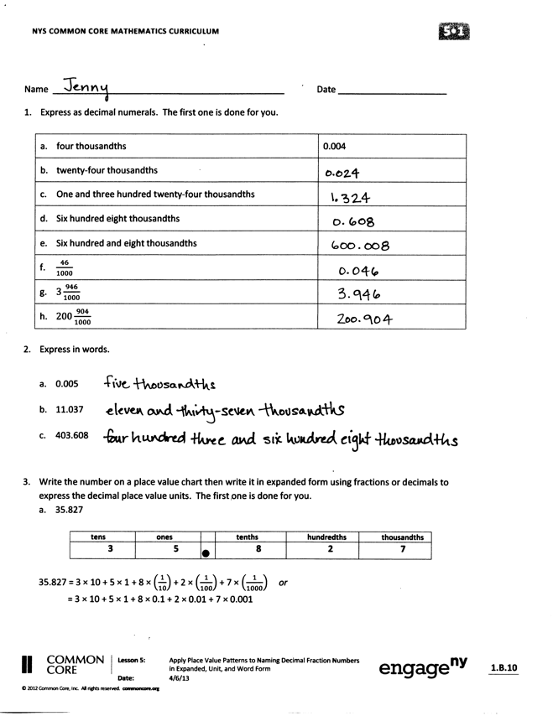
Students should do their personal best to complete the Problem Set within the allotted 10 minutes. For some classes, it may be appropriate to modify the assignment by specifying which problems they work on first. Some problems do not specify a method for solving. Students solve these problems using the RDW approach used for Application Problems.
Student Debrief (10 minutes)
Lesson Objective: Name decimal fractions in expanded, unit, and word forms by applying place value reasoning.
The Student Debrief is intended to invite reflection and active processing of the total lesson experience.
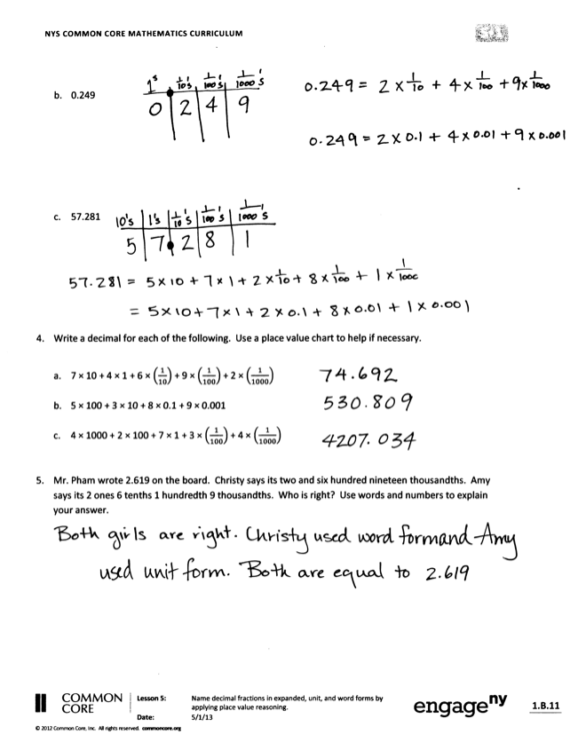
Invite students to review their solutions for the Problem Set. They should check work by comparing answers with a partner before going over answers as a class. Look for misconceptions or misunderstandings that can be addressed in the Debrief. Guide students in a conversation to debrief the Problem Set and process the lesson.
You may choose to use any combination of the questions below to lead the discussion.
- Which tasks in Problem 1 are alike? Why?
- What is the purpose of writing a decimal number in expanded form using fractions? What was the objective of our lesson today?
- Compare your answers to Problem 1(d) and 1(e). What is the importance of the word and when naming decimals in standard form?
- When might expanded form be useful as a calculation tool? (It helps us see the like units and could help to add and subtract mentally.)
- How is expanded form related to the standard form of a number?

Exit Ticket (3 minutes)
After the Student Debrief, instruct students to complete the Exit Ticket. A review of their work will help you assess the students’ understanding of the concepts that were presented in the lesson today and plan more effectively for future lessons. You may read the questions aloud to the students.

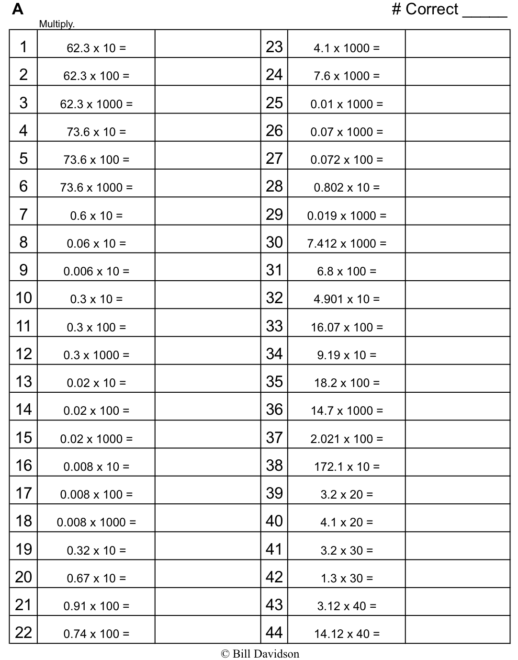

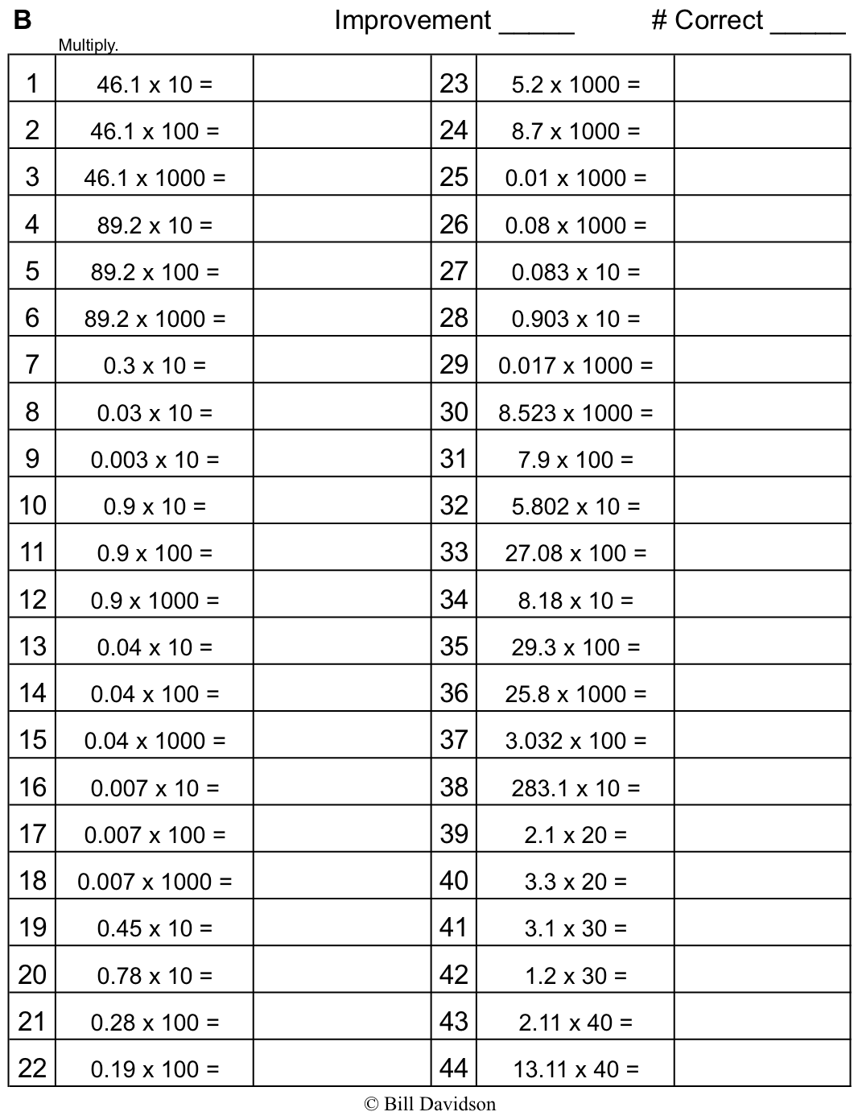

Name Date
- Express as decimal numerals. The first one is done for you.

- Four thousandths | 0.004
  - Twenty-four thousandths
- One and three hundred twenty-four thousandths
- Six hundred eight thousandths
- Six hundred and eight thousandths
- $\frac{46}{1000}$
- $3\frac{946}{1000}$
- $200\frac{904}{1000}$

- Express each of the following values in words.

- 0.005 | ______________________________________________________________________
- 11.037 | ______________________________________________________________________
- 403.608 | ______________________________________________________________________

- Write the number on a place value chart. Then, write it in expanded form using fractions or decimals to express the decimal place value units. The first one is done for you.
  - 35.827

Tens | Ones |  | Tenths | Hundredths | Thousandths
3 | 5 |  | 8 | 2 | 7

35.827 = 3 $×$ 10 + 5 $×$ 1 + 8 $×$ $\left(\frac{1}{10}\right)$ + 2 $×$ $\left(\frac{1}{100}\right)$ + 7 $×$ $\left(\frac{1}{1000}\right)$ or
= 3 $×$ 10 + 5 $×$ 1 + 8 $×$ 0.1 + 2 $×$ 0.01 + 7 $×$ 0.001

  - 0.249

  - 57.281

- Write a decimal for each of the following. Use a place value chart to help, if necessary.

- 7 × 10 + 4 × 1 + 6 × $\left(\frac{1}{10}\right)$ + 9 × $\left(\frac{1}{100}\right)$ + 2 × $\left(\frac{1}{1000}\right)$
- 5 × 100 + 3 × 10 + 8 × 0.1 + 9 × 0.001
- 4 × 1,000 + 2 × 100 + 7 × 1 + 3 × $\left(\frac{1}{100}\right)$ + 4 × $\left(\frac{1}{1000}\right)$

- Mr. Pham wrote 2.619 on the board. Christy says it is two and six hundred nineteen thousandths. Amy says it is 2 ones 6 tenths 1 hundredth 9 thousandths. Who is right? Use words and numbers to explain your answer.

Name Date
- Express nine thousandths as a decimal.

- Express twenty-nine thousandths as a fraction.

- Express 24.357 in words.

- Write the expanded form using fractions or decimals.

- Express in unit form.

Name Date
- Express as decimal numerals. The first one is done for you.

- Five thousandths | 0.005
- Thirty-five thousandths
- Nine and two hundred thirty-five thousandths
- Eight hundred and five thousandths
- $\frac{8}{1000}$
- $\frac{28}{1000}$
- $7\frac{528}{1000}$
- $300\frac{502}{1000}$

- Express each of the following values in words.
- 0.008 ______________________________________________________________________
- 15.062 ______________________________________________________________________
- 607.409 ______________________________________________________________________

- Write the number on a place value chart. Then, write it in expanded form using fractions or decimals to express the decimal place value units. The first one is done for you.

  - 27.346
Tens | Ones |  | Tenths | Hundredths | Thousandths
2 | 7 |  | 3 | 4 | 6

27.346 = 2 $×$ 10 + 7 $×$ 1 + 3 $×$ $\left(\frac{1}{10}\right)$ + 4 $×$ $\left(\frac{1}{100}\right)$ + 6 $×$ $\left(\frac{1}{1000}\right)$ or
27.346 = 2 $×$ 10 + 7 $×$ 1 + 3 $×$ $0.1$+ 4 $×$ 0.01 + 6 $×$ 0.001

  - 0.362

  - 49.564

- Write a decimal for each of the following. Use a place value chart to help, if necessary.

- 3 $×$ 10 + 5 $×$ 1 + 2 $×$ $\left(\frac{1}{10}\right)$ + 7 $×$ $\left(\frac{1}{100}\right)$ + 6 $×$ $\left(\frac{1}{1000}\right)$
- 9 $×$ 100 + 2 $×$ 10 + 3 $×$ 0.1 + 7 $×$ 0.001
- 5 $×$ 1000 + 4 $×$ 100 + 8 $×$ 1 + 6 $×$ $\left(\frac{1}{100}\right)$ + 5 $×$ $\left(\frac{1}{1000}\right)$

- At the beginning of a lesson, a piece of chalk is 4.875 inches long. At the end of the lesson, it is 3.125 inches long. Write the two amounts in expanded form using fractions.

- At the beginning of the lesson:

- At the end of the lesson:

- Mrs. Herman asked the class to write an expanded form for 412.638. Nancy wrote the expanded form using fractions, and Charles wrote the expanded form using decimals. Write their responses.

Thousandths
Hundredths
Tenths
Ones
Tens
Hundreds
Thousands

thousands through thousandths place value chart

