Lesson 10
Objective: Multiply decimal fractions with tenths by multi-digit whole numbers using place value understanding to record partial products.

Suggested Lesson Structure
 Fluency Practice (12 minutes)
 Application Problem (6 minutes)
 Concept Development (32 minutes)
 Student Debrief (10 minutes)
Total Time (60 minutes)
Fluency Practice (12 minutes)
- Multiply then Divide by the Same Number 5.NBT.2 (6 minutes)
- Decompose Decimals 5.NBT.3 (6 minutes)
Multiply then Divide by the Same Number (6 minutes)
Note: This fluency activity reviews what happens when any number or expression is divided, and then multiplied by the same number in preparation for today's lesson.
T: 3 × 2 is…?
S: 6.
T: 3 × 2 × 10 ÷ 10 is…?
S: 6.
T: 5 × 0.3 is…?
S: 1.5.
T: 5 × 0.3 × 10 ÷ 10 is…?
S: 1.5.
T: (Continue the sequence with 3 × 2.5 and 2 × 3.4.)
T: Why are the products the same when we multiply by 10 and then divide by 10?
S: You are undoing what you did when you multiplied by 10. We’re moving over one place to the left on the place value chart, and then back to the right again. Because it’s just like multiplying by 1.

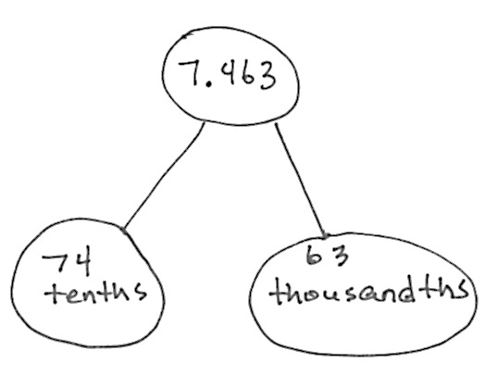
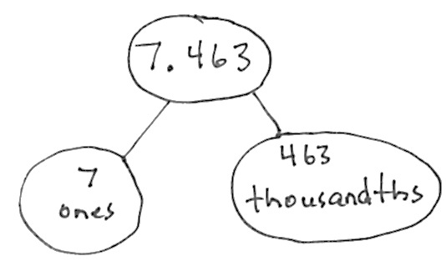
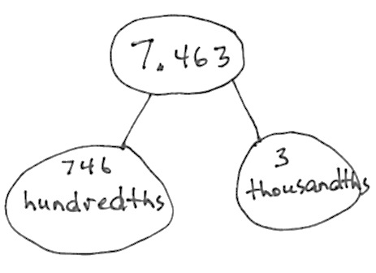
Decompose Decimals (6 minutes)
Materials: (S) Personal white board
Note: This fluency activity reviews decimal place value concepts and emphasizes part-whole decomposition through the use of the number bond.
T: (Project 7.463.) Say the number.
S: 7 and 463 thousandths.
T: Represent this number in a two-part number bond with ones as one part and thousandths as the other part (pictured to the right).
S: (Draw.)
T: Represent it again with tenths and thousandths.
T: Represent it again with hundredths and thousandths.
Follow the same process for 8.972 and 6.849
Application Problem (6 minutes)
The fifth-grade craft club is making aprons to sell. Each apron takes 1.25 yards of fabric that costs $3 per yard and 4.5 yards of trim that costs $2 per yard. What does it cost the club to make one apron? If the club wants to make $1.75 profit on each apron, how much should they charge per apron?
Note: This problem requires students to not only use their G5–Module 1 knowledge of decimal by
single-digit multiplier, but also asks them to reason about a start unknown problem type.
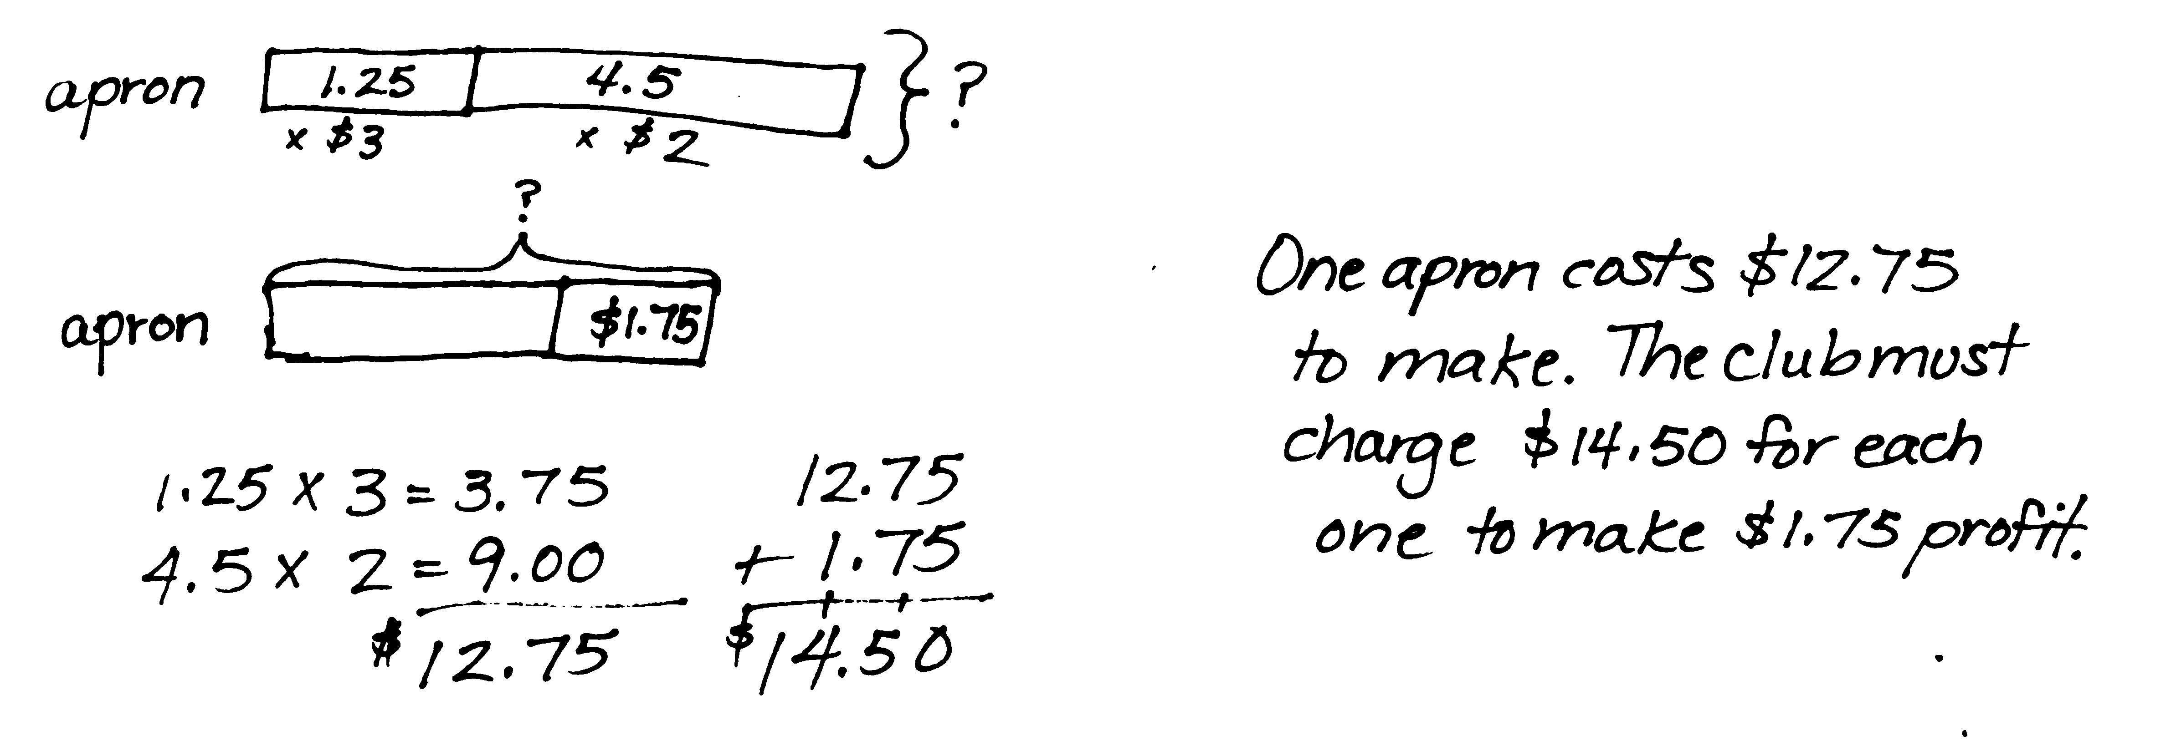
Concept Development (32 minutes)

NOTES ON
MULTIPLE MEANS
OF REPRESENTATION:
The decimal multiplication in this and following lessons builds on the concept of whole number multiplication in earlier module lessons and the single -digit decimal multiplication from Module 1. It is important for students to note that, because multiplication is commutative, multiplication sentences may be notated in any order. In this part of the module, the decimal factor will be designated as the unit (multiplicand—the what that is being multiplied), while the whole number will be treated as the multiplier (the how many copies number). This interpretation allows students to build on the repeated addition concept of multiplying whole numbers, which has formed the basis of the area model as students understand it. This makes the distributive property and partial products of the algorithm a direct parallel to whole number work.

Materials: (S) Personal white board
Problems 1–3
43 × 2.4
3.5 × 42
15.6 × 73
T: (Write 43 × 2.4 on the board.) Round the factors to estimate the product.
S: (Show.) 40 × 2 = 80.
T: Predict whether our estimate is greater than or less than the actual product.
S: Less than because both factors were rounded to numbers less than the actual factors. Our actual answer might be about 90.
T: We have 43 units of 2.4. I’d like to rename 2.4 using only tenths. How many tenths would that be?
S: 24 tenths.
T: Decompose those 24 tenths into expanded form along the length of our rectangle. Let’s write tenths out to the right to remind us of the unit. (Demonstrate.)

S: (Draw.)
T: Our rectangle’s width is 43 whole units. Decompose 43 into expanded form along the width.
S: (Draw.)
T: What partial products do the rows represent?
S: 3 × 24 tenths and 40 × 24 tenths.
T: Find the partial products and the final product.
S: (Multiply the cells and add the rows.)
T: We found that we have 1,032 of what unit?
S: Tenths.
T: Write 1,032 tenths in standard form.
S: 103.2.
T: Compare this to our estimate. Is our product reasonable?
S: Our estimate was 80, and our exact product is 103.2. Our product is reasonable.
T: Let’s solve this same problem using the algorithm. (Write 24 tenths × 43 on the board as shown on previous page.) When we find the product, we have to remember that we copied tenths. Solve this problem, and then share with your partner.
S: (Work and share.)
T: Look back at your area model. Find these partial products in your algorithm. Turn and talk.
S: 72 is the first row in the area model and the first row in the algorithm. I see 72 tenths in both of them. I see 960 tenths in the second row of both.
T: We’ve found 1,032 tenths using a second strategy. Let’s write it in standard form.
S: 103.2.
It’s important to have students recognize that the area model drawn using whole number values would be 10 times as wide as the model that would be drawn using tenths.
T: We don’t have to do this process in such a long way. Here is a simplifying shortcut for multiplying
by 1. We can first multiply one of the factors by 10 and then divide the product by 10.
The student demonstrates this with the algorithm by multiplying by 10, and then dividing by 10. “It’s like multiplying by 1! 2 times 3 times 10 divided by 10 is 6. See, it’s the same idea, just with bigger numbers.”
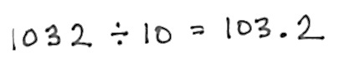
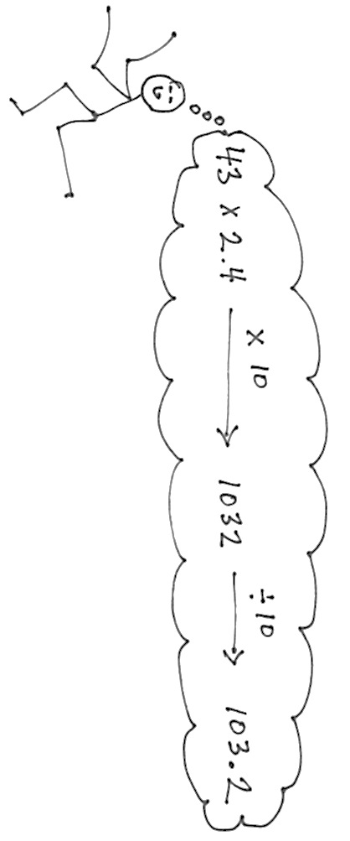

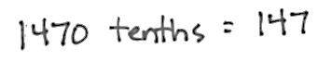
T: Solve 3.5 × 42. Round the factors, and estimate the product.
S: 4 × 40 = 160.
T: Naming 3.5 using tenths, draw an area model to show 3.5 × 42. Check your work with your partner. Remember to compare your final product with your estimate to see if your answer is reasonable.
S: (Work.)
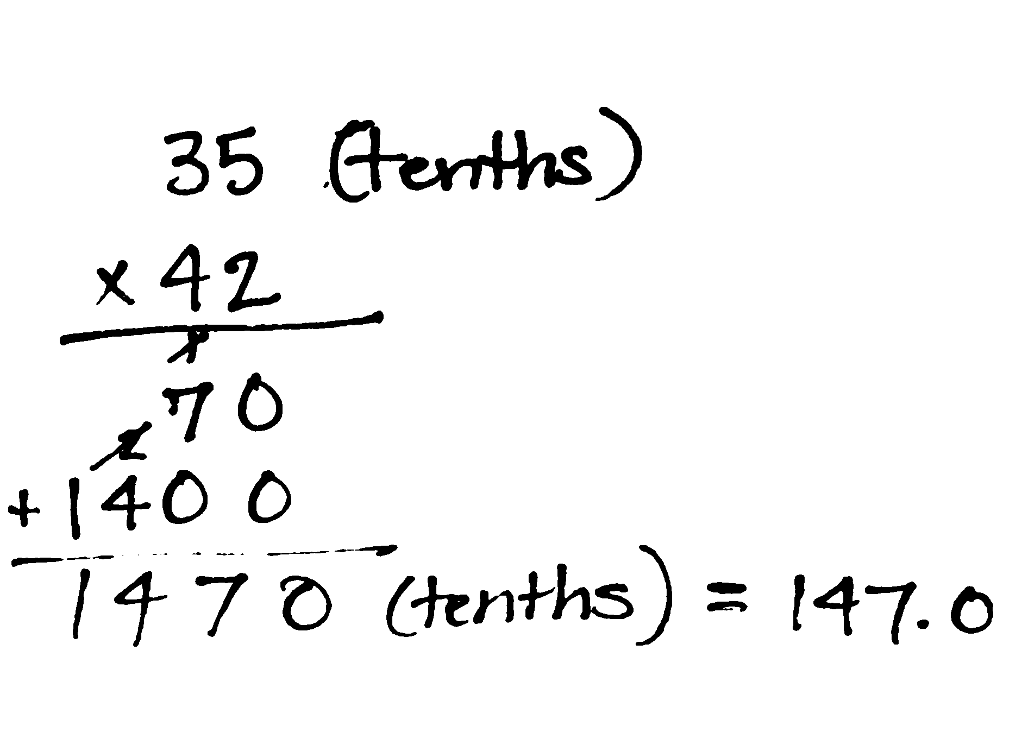
T: Partner A, confirm this product by naming 3.5 in tenths and using the standard algorithm to solve. Partner B, confirm this product by first multiplying 3.5 by 10 and then multiplying by 42. Then, dividing the product by 10.
T: How are these two ways of thinking different? Turn and talk to your partner.
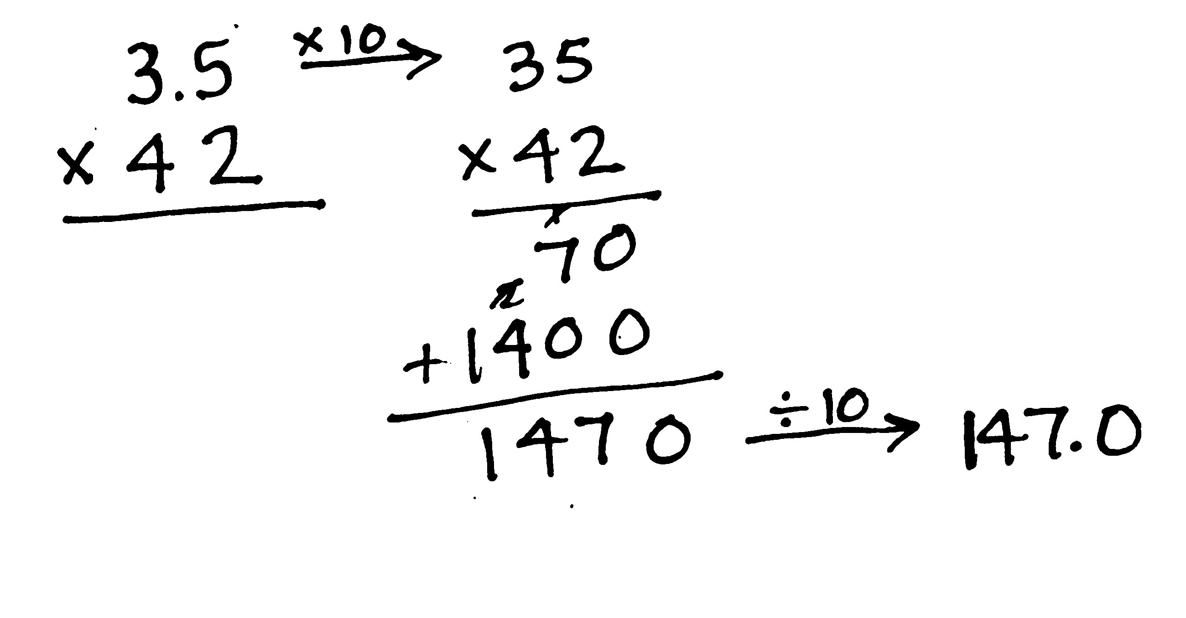
S: In the first way, we thought of 3.5 as 35 tenths. After we multiplied by 42, we still had tenths. In the second way, we first multiplied 3.5 times 10, and then multiplied by 42. Then, used the final product to divide by 10. Multiplying by 10, and then dividing by 10 doesn’t change the value of the answer because we are really just multiplying by 1.
T: How are these two ways of thinking similar? Turn and talk to your partner.
S: In both cases, we needed to think about the original units of the first factor. In both cases, we had the same partial products. In both cases, the multiplication process was exactly the same. After we adjusted the product, the answer to both was the same.
Repeat the sequence for 15.6 × 73. Have students compare this problem to the others in the set, making sure to elicit from them that the presence of the third column in the area model does not change the thinking behind the area model, nor does it affect the partial products. Also, encourage students to think about multiplying the decimal factor by 10 and then adjusting the product through division by 10.
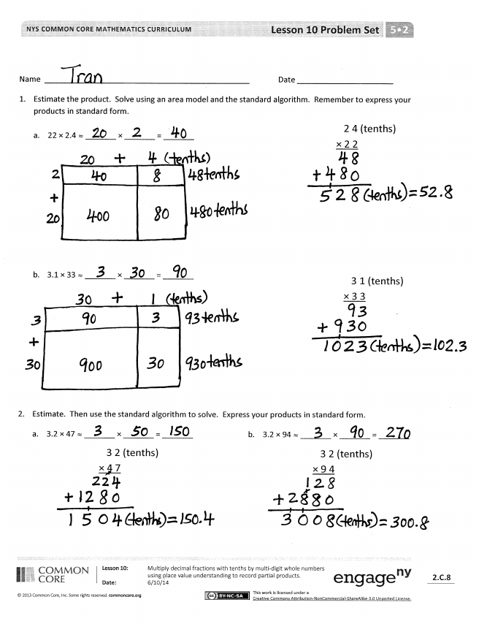
Problem Set (10 minutes)
Students should do their personal best to complete the Problem Set within the allotted 10 minutes. For some classes, it may be appropriate to modify the assignment by specifying which problems they work on first. Some problems do not specify a method for solving. Students should solve these problems using the RDW approach used for Application Problems.
Student Debrief (10 minutes)
Lesson Objective: Multiply decimal fractions with tenths by multi-digit whole numbers using place value understanding to record partial products.
The Student Debrief is intended to invite reflection and active processing of the total lesson experience.
Invite students to review their solutions for the Problem Set. They should check work by comparing answers with a partner before going over answers as a class. Look for misconceptions or misunderstandings that can be addressed in the Debrief. Guide students in a conversation to debrief the Problem Set and process the lesson.
You may choose to use any combination of the questions below to lead the discussion.
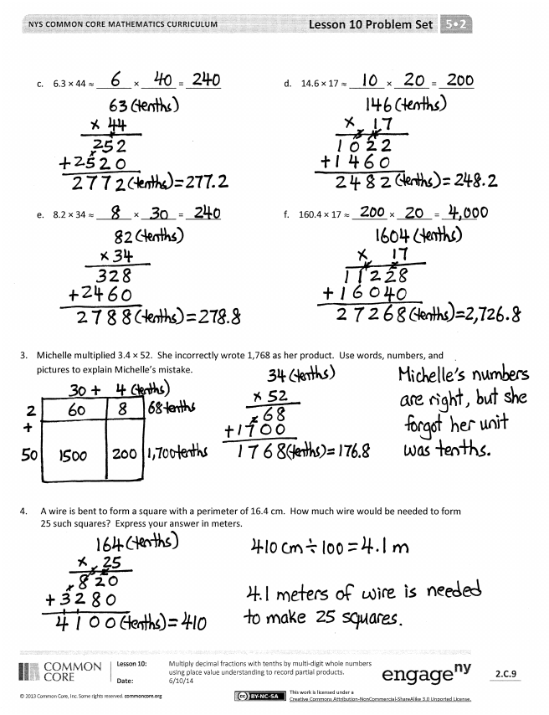
- Discuss Michelle’s error in Problem 3 by allowing students to share their representations and explanations. Some students may explain her error by saying that she should have said 1,768 tenths. Others may offer that she should have written her answer in standard form as 176.8. Either explanation’s premise is that Michelle did not consider the unit of her final product.
- How does being fluent in whole number multi-digit multiplication help you multiply decimals? (Focus student attention on the notion that the algorithm is exactly the same, but different units must be considered when multiplying decimals.)
- Extend student reasoning about decimal multiplication by offering a case, such as 0.3 × 42. Ask students how they would draw an area model and/or record this case vertically. Point out that the convention is to write the numeral with the most digits as the “top” number in the algorithm, but that this is not expressly necessary. Ask students to discuss how putting the single-digit numeral (3 tenths) as the top number affects the recording of partial products?
(It does not. The process is the same. The order is different.)
Exit Ticket (3 minutes)
After the Student Debrief, instruct students to complete the Exit Ticket. A review of their work will help you assess the students’ understanding of the concepts that were presented in the lesson today and plan more effectively for future lessons. You may read the questions aloud to the students.

Name Date
- Estimate the product. Solve using an area model and the standard algorithm. Remember to express your products in standard form.
3 1 (tenths) × 3 3
2 4 (tenths) × 2 2
- 22 × 2.4 ≈ _______ × _______ = _______

- 3.1 × 33 _______ × _______ = _______

- Estimate. Then, use the standard algorithm to solve. Express your products in standard form.

- 3.2 × 47 ≈ _______ × _______ = _______ b. 3.2 × 94 ≈ _______ × _______ = _______
3 2 (tenths) × 9 4
3 2 (tenths) × 4 7

- 6.3 × 44 ≈ _______ × _______ = _______ d. 14.6 × 17 ≈ _______ × _______ = _______

- 8.2 × 34 ≈ _______ × _______ = _______ f. 160.4 × 17 ≈ _______ × _______ = _______

- Michelle multiplied 3.4 × 52. She incorrectly wrote 1,768 as her product. Use words, numbers, and/or pictures to explain Michelle’s mistake.

- A wire is bent to form a square with a perimeter of 16.4 cm. How much wire would be needed to form 25 such squares? Express your answer in meters.

Name Date
- Estimate the product. Solve using an area model and the standard algorithm. Remember to express your products in standard form.

- 33.2 × 21 ≈ _______ × _______ = _______

- 1.7 × 55 ≈ _______ × _______ = _______

- If the product of 485 × 35 is 16,975, what is the product of 485 × 3.5? How do you know?

Name Date
- Estimate the product. Solve using an area model and the standard algorithm. Remember to express your products in standard form.
1 2 (tenths) × 5 3
- 53 × 1.2 ≈ _______ × _______ = _______

2 1 (tenths) × 8 2
- 2.1 × 82 ≈ _______ × _______ = _______

- Estimate. Then, use the standard algorithm to solve. Express your products in standard form.

- 4.2 × 34 ≈ _______ × _______ = _______ b. 65 × 5.8 ≈ _______ × _______ = _______
5 8 (tenths) × 6 5
4 2 (tenths) × 3 4

- 3.3 × 16 ≈ _______ × _______ = _______ d. 15.6 × 17 ≈ _______ × _______ = _______

- 73 × 2.4$≈$_______ × _______ = _______ f. 193.5 × 57 ≈ _______ × _______ = _______

- Mr. Jansen is building an ice rink in his backyard that will measure 8.4 meters by 22 meters. What is the area of the rink?

- Rachel runs 3.2 miles each weekday and 1.5 miles each day of the weekend. How many miles will she have run in 6 weeks?

