Lesson 11
Objective: Multiply decimal fractions by multi-digit whole numbers through conversion to a whole number problem and reasoning about the placement of the decimal.

Suggested Lesson Structure
 Fluency Practice (12 minutes)
 Application Problem (6 minutes)
 Concept Development (32 minutes)
 Student Debrief (10 minutes)
Total Time (60 minutes)
Fluency Practice (12 minutes)
- Sprint: Multiply Decimals 5.NBT.2 (8 minutes)
- Multiply then Divide by the Same Number 5.NBT.2 (4 minutes)
Sprint: Multiply Decimals (8 minutes)
Materials: (S) Multiply Decimals Sprint
Note: This fluency activity provides single-digit multiplication practice with decimals. This provides practice with computation required during Concept Development.
Multiply then Divide by the Same Number (4 minutes)
Note: This fluency activity reviews what happens when any number or expression is divided and then multiplied by the same number in preparation for today's lesson.
T: 3 × 4.1 is…?
S: 12.3.
T: 12.3 × 10 ÷ 10 is…?
S: 12.3.
T: 3 × 4.1 × 1 is…?
S: 12.3.
T: (Repeat with 3 × 2.4.)
T: 3 × 4 × 17.6 ÷ 17.6 is…?
S: 12.
Application Problem (6 minutes)
Mr. Mohr wants to build a rectangular patio using concrete tiles that are 12 square inches. The patio will measure 13.5 feet by 43 feet. What is the area of the patio? How many concrete tiles will he need to complete the patio?
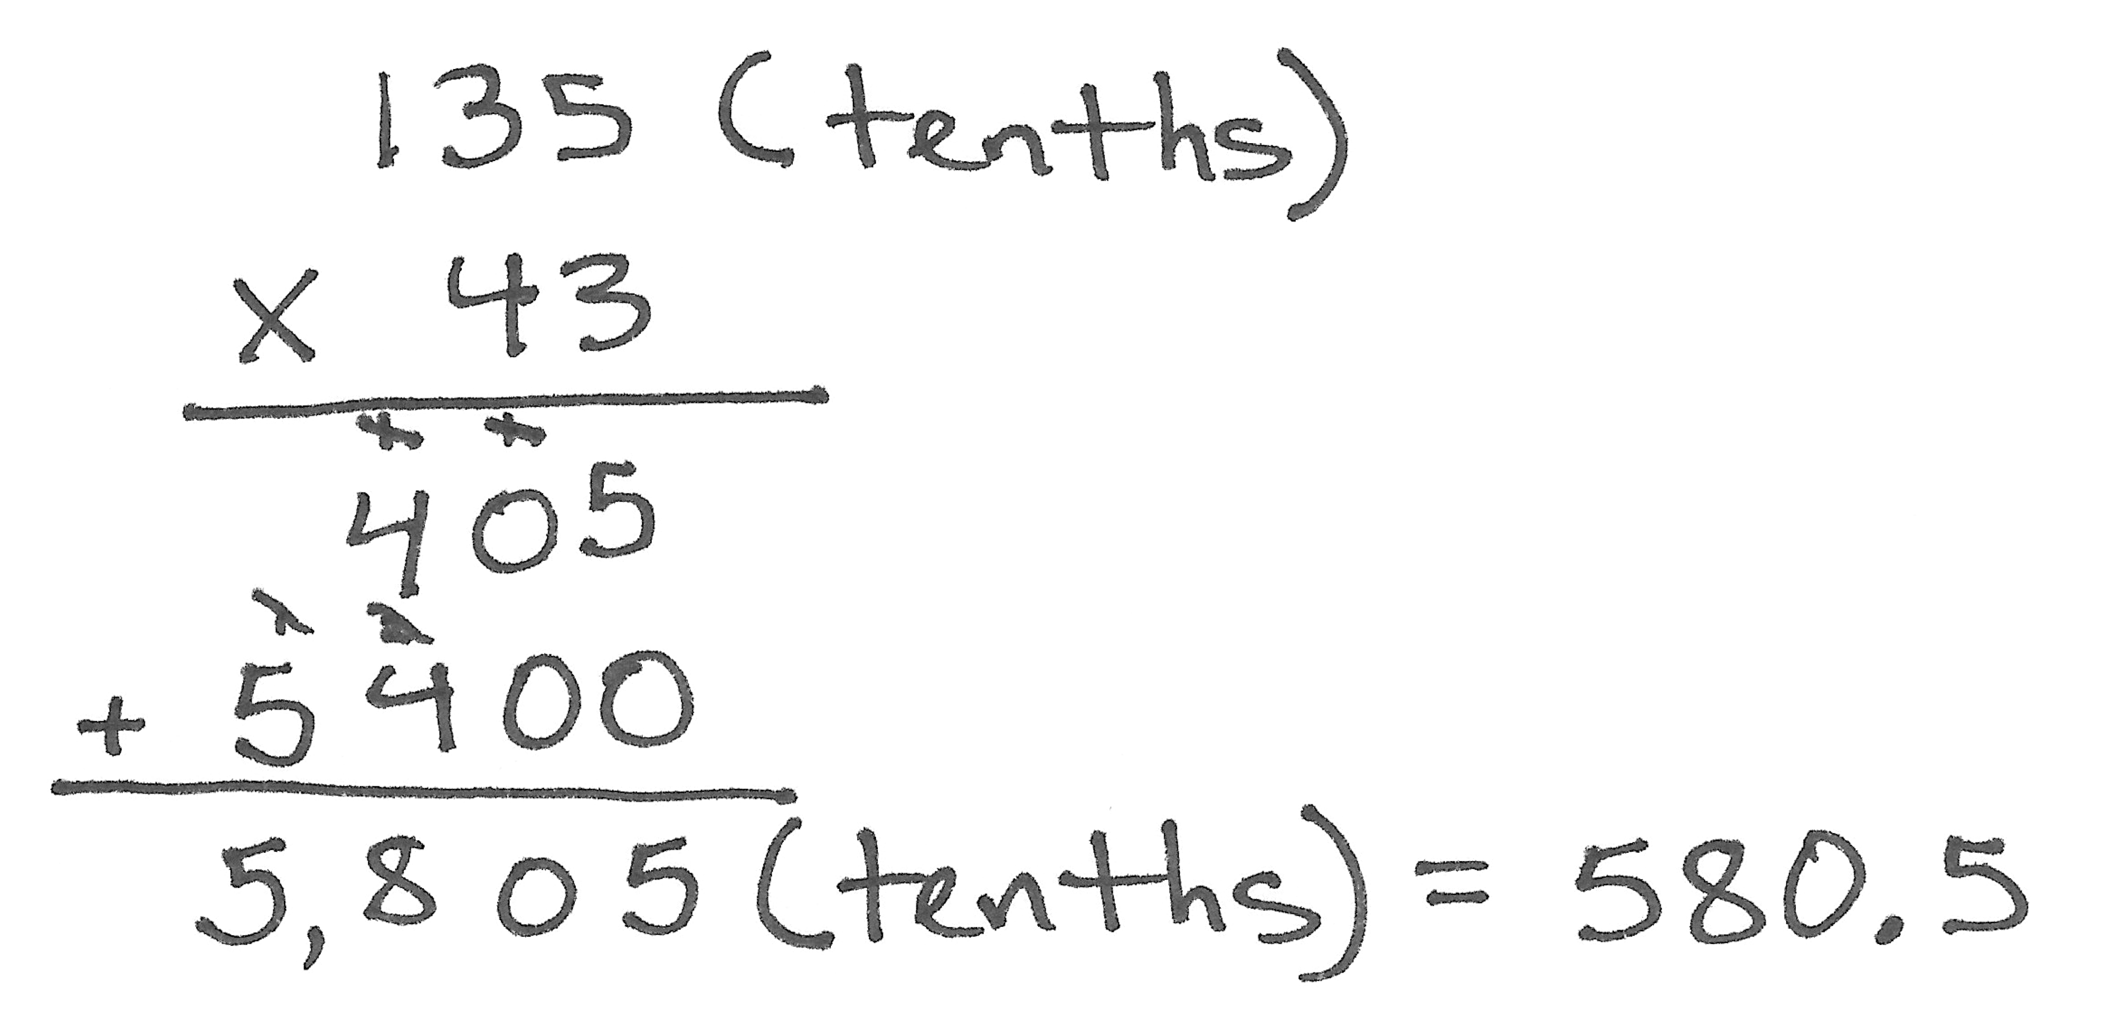

Note: This Application Problem asks students to use the decimal multiplication concepts from Lesson 10. Additionally, students must demonstrate understanding of area and use that understanding to reason with respect to the number of tiles needed in the second question. This problem involves a decimal factor of tenths. Use this problem as a springboard for today’s lesson, which extends to multiplication of decimal factors of hundredths.
Concept Development (32 minutes)
NOTES ON
MULTIPLE MEANS
OF ACTION AND EXPRESSION:
The compensation strategy of multiplying a decimal number by a multiple of 10 and then dividing the product by the same multiple of 10 may require some time for students to internalize. The following scaffolds may be appropriate:
- Encourage students to draw the think bubble next to their work, or encourage them to label the units.
- Encourage students who are struggling with the standard algorithm to use the area model. The area model provides support by calculating all of the partial products of the problem.

Materials: (S) Personal white board
Problems 1–3
7.38 × 41
8.26 × 128
82.51 × 63
T: (Write 7.38 × 41.) Compare this problem to our Application Problem.
S: It’s still multiplication of a decimal by a whole number. The decimal in the Application Problem was tenths. This is hundredths.
T: Estimate this product.
S: 7 × 40 ÷ 280.
T: Predict whether our estimate is greater than or less than the actual product.
S: The estimate is less than because both factors were rounded to numbers less than the actual factors. Our actual answer will be more than 280, but it will still be in the hundreds.
T: We have 41 units of 7.38. I’d like to rename 7.38 using only hundredths. How many hundredths would that be? How do you know?
S: 738 hundredths because 7 is 700 hundredths plus another 38 hundredths equals 738 hundredths. 7 and 38 hundredths times 100 equals 738 ones.
T: Let’s use an area model to find the actual product of this expression. Decompose those 738 hundredths into expanded form along the length of our rectangle. Write hundredths out to the right to remind us that we’ve named 7.38 as hundredths. (Demonstrate.)
S: (Draw area model.)
T: Our rectangles width is 41 whole units. Decompose 41 into expanded form along the width.
S: (Draw area model.)
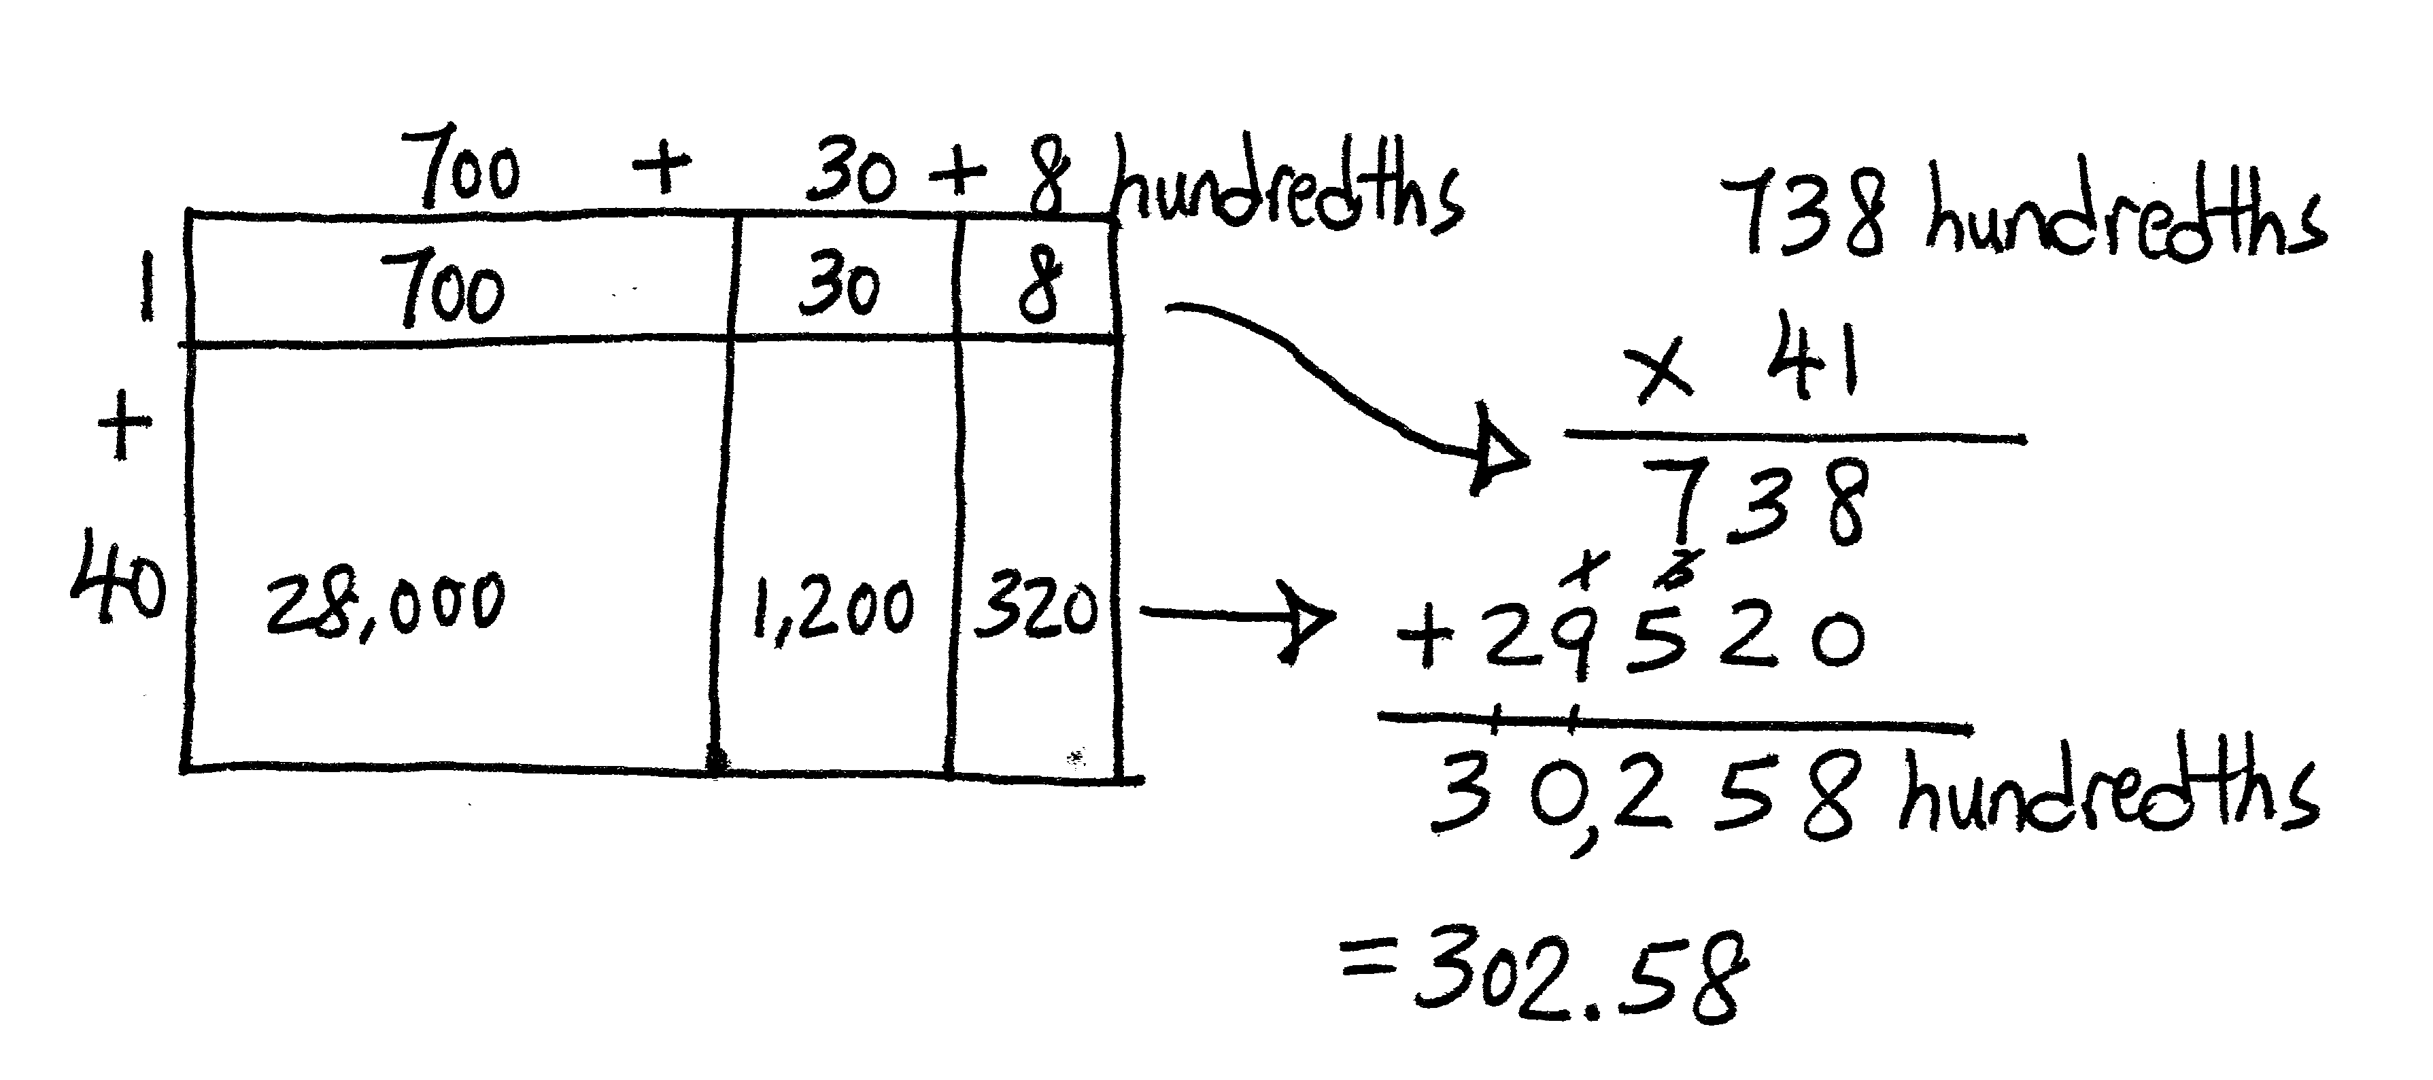
T: What two partial products do these rows represent?
S: 1 × 738 hundredths and 40 × 738 hundredths.
T: Find the partial products and the final product.
S: (Multiply the cells and add the rows.)
T: We found that we have 30,258 of what unit?
S: Hundredths.
T: We need to write this in standard form. How can our estimate help us convert our product back to wholes and hundredths?
S: The estimate told us that our answer was in the hundreds, not the ten-thousands or the thousands.
30,258 is about 100 times as large as our estimate said the real answer should be, so we need to divide by 100 to make the answer make sense.
NOTES ON
MULTIPLE MEANS
OF REPRESENTATION:
Students may discover the pattern that the number of decimal digits in the factors equals the number of decimal digits in the product. While this can be a useful observation, keep students focused on the reason for the pattern. “We multiplied a factor by a power of 10, therefore we must divide the product by the same power of 10 to adjust it.”

T: What is 30,258 hundredths written in standard form?
S: 302.58.
T: Let’s solve this same problem using the algorithm. Yesterday, we rewrote our first factor as a whole number with the unit name to the right. (Write 738 hundredths × 41 on the board as shown.) Today, let’s think about the units without removing the decimal from our first factor. We see 7.38, but we think 738 hundredths. Multiply 738 × 41 and find the product. Look back at your area model to confirm the partial products in your algorithm.
S: (Work.)
T: This product is 100 times as large as the product of our original problem. What should we do to adjust this product so that it answers our original problem of 7.38 × 41?
S: We should divide by 100.
T: Let me record what I hear you saying. (Write on board as shown.) So, is our adjusted product of 302.58 reasonable given our estimate?
S: Yes.
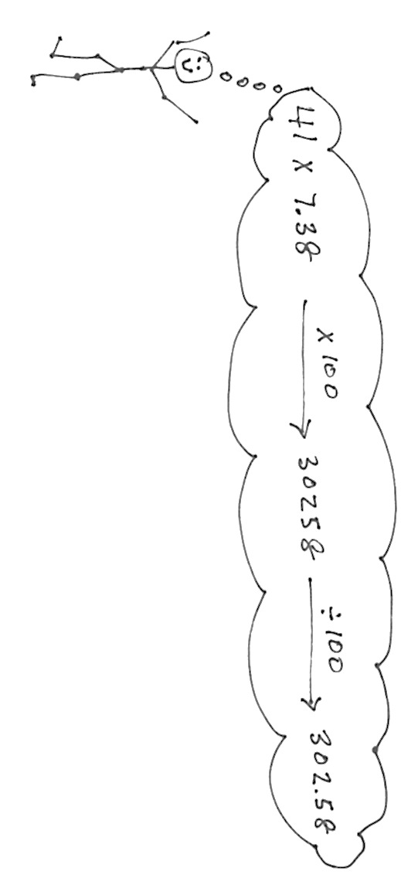
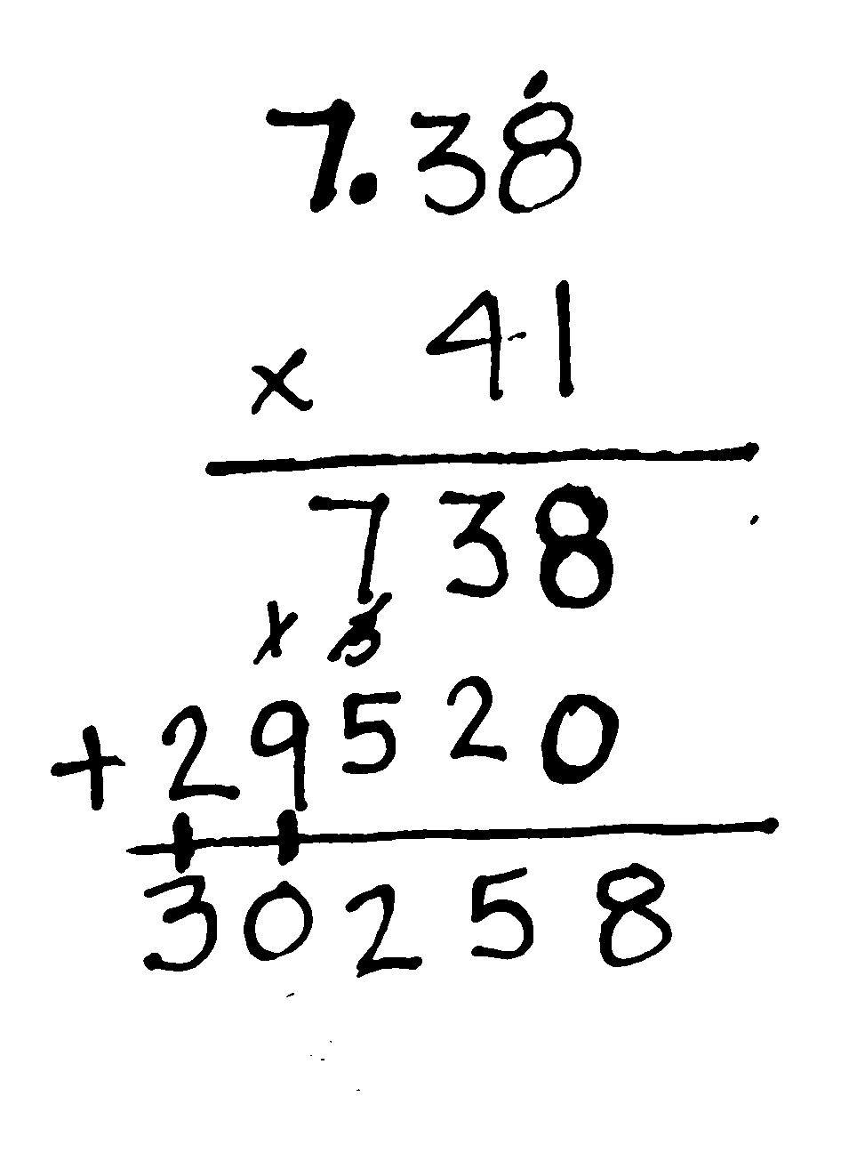
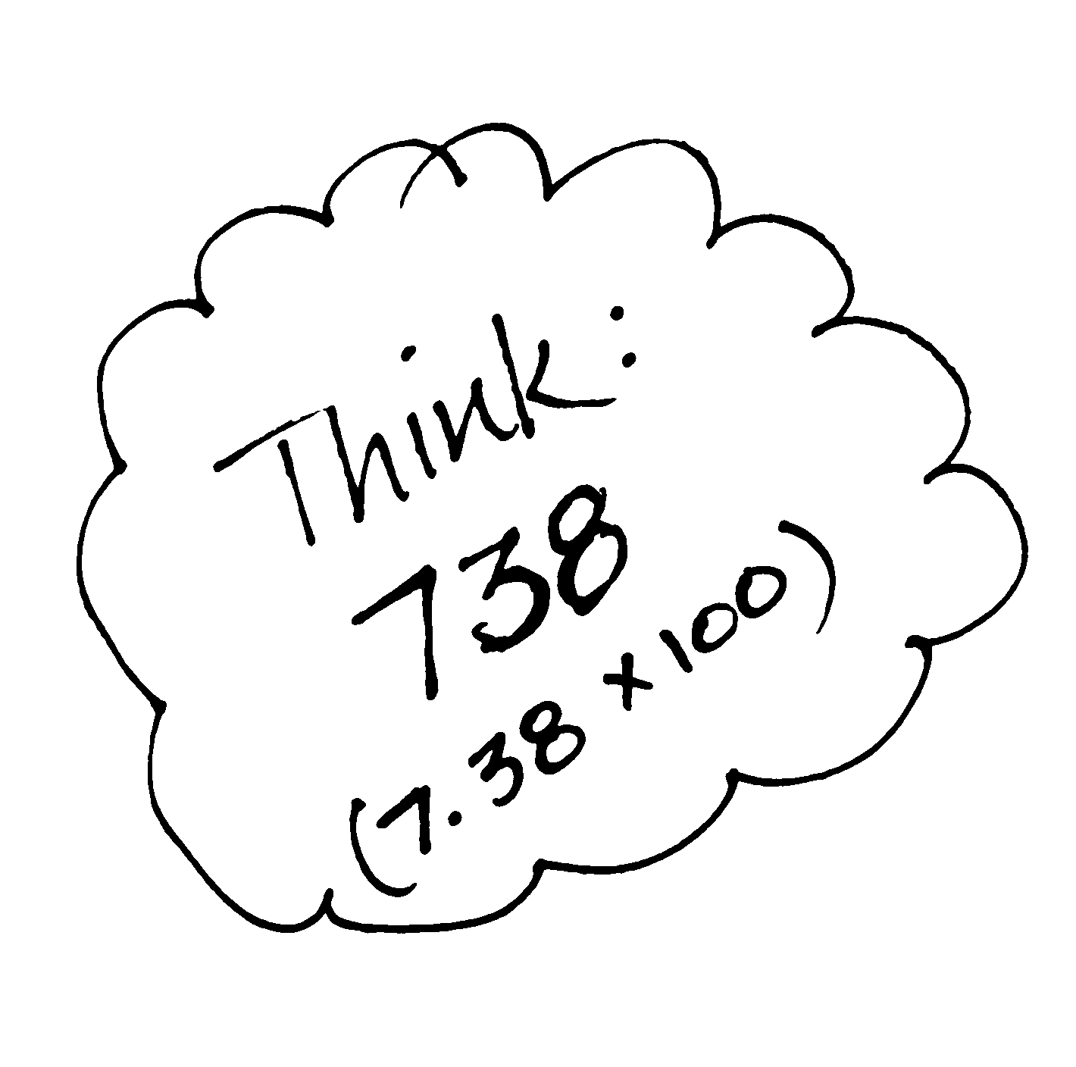
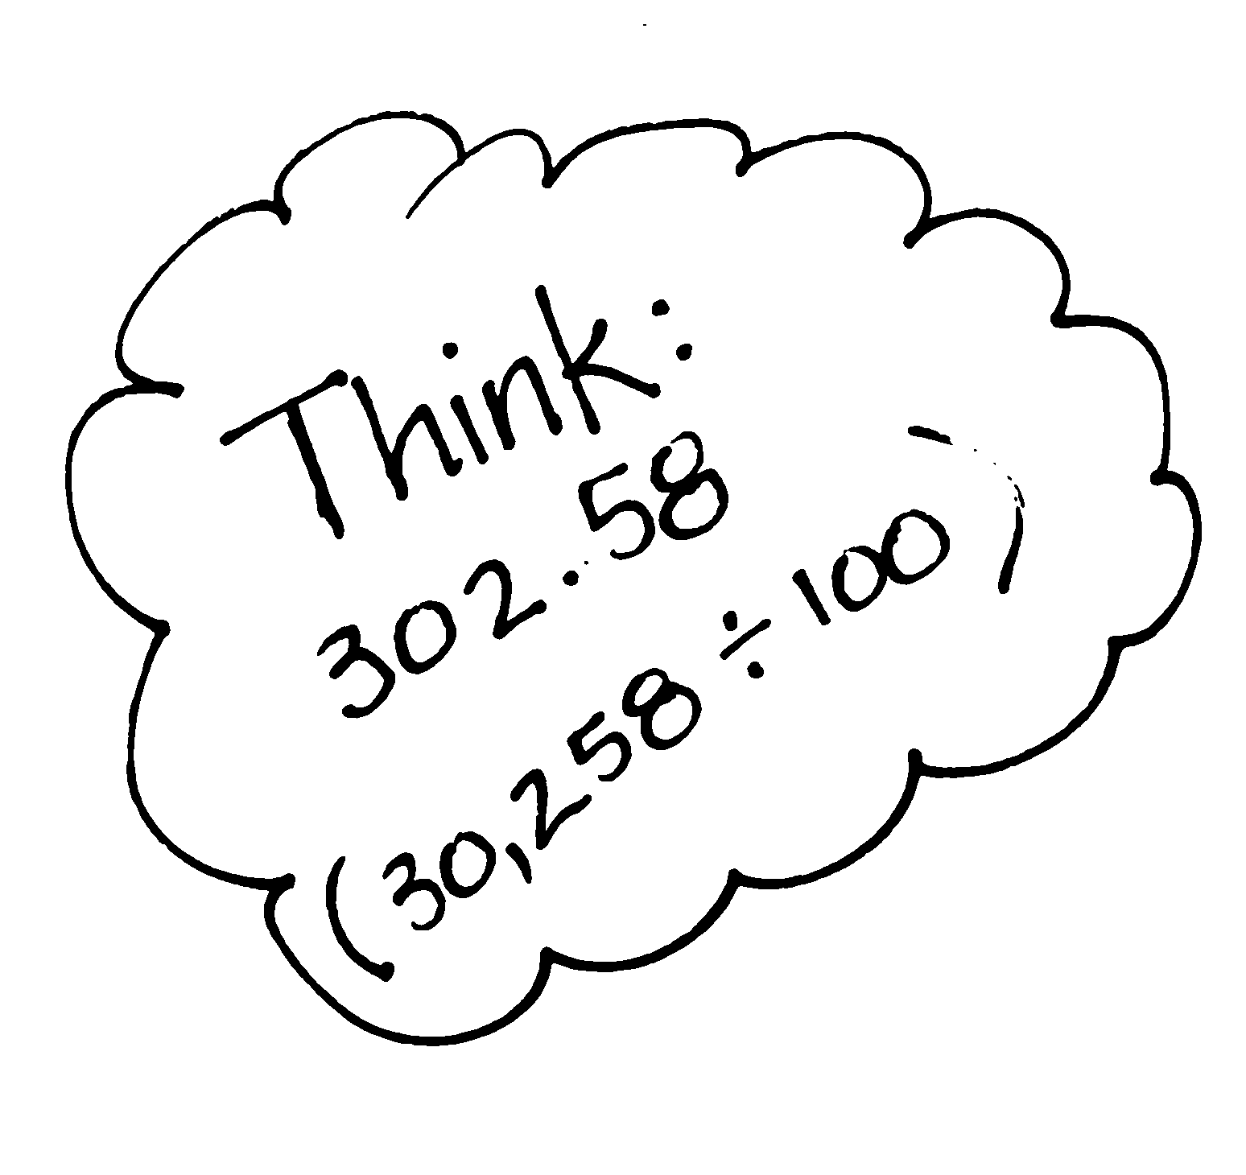
Work with the other two problems in this set as you feel is best for your students. Continue with other examples, if necessary. Encourage students who struggle with the algorithm to use the area model. Allow students to forego the area model if they are proficient with the algorithm.
Problem Set (10 minutes)
Students should do their personal best to complete the Problem Set within the allotted 10 minutes. For some classes, it may be appropriate to modify the assignment by specifying which problems they work on first. Some problems do not specify a method for solving. Students should solve these problems using the RDW approach used for Application Problems.
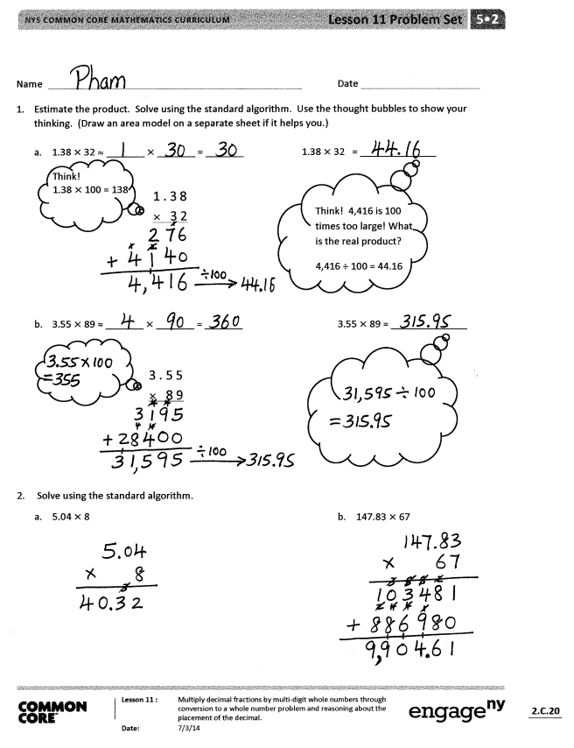
Student Debrief (10 minutes)
Lesson Objective: Multiply decimal fractions by multi-digit whole numbers through conversion to a whole number problem and reasoning about the placement of the decimal.
The Student Debrief is intended to invite reflection and active processing of the total lesson experience.
Invite students to review their solutions for the Problem Set. They should check work by comparing answers with a partner before going over answers as a class. Look for misconceptions or misunderstandings that can be addressed in the Debrief. Guide students in a conversation to debrief the Problem Set and process the lesson.
You may choose to use any combination of the questions below to lead the discussion.
- Have students share what they wrote in the think bubbles for Problem 1, and compare approaches.
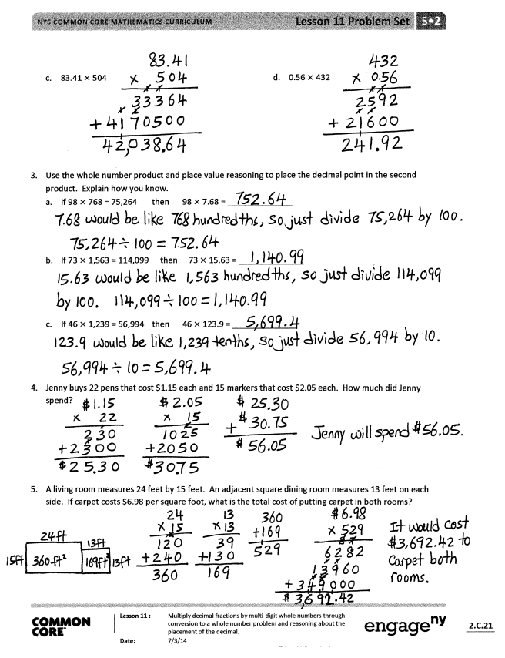
- Have students share their strategies for Problem 2(d). This item differs from the others in the Problem Set because it contains a decimal of less than one. Does this affect the process for solving? Why or why not? (It is important to note with students that, while convention dictates the number with more digits is put on top in the algorithm, this is not strictly necessary.)
- Problem 3 provides an opportunity for students to reason about the compensation strategy without the burden of the actual multiplication. Explore the relationships between the relative size of the factors in the whole number problems and the factors in the decimal problems and resultant relationships between the products. (One factor in the whole number problem is 100 times as large as the corresponding decimal factor. This results in products that share the same digits, but are one hundredth the size. Refer to the second UDL box in the lesson.)
Exit Ticket (3 minutes)
After the Student Debrief, instruct students to complete the Exit Ticket. A review of their work will help you assess the students’ understanding of the concepts that were presented in the lesson today and plan more effectively for future lessons. You may read the questions aloud to the students.

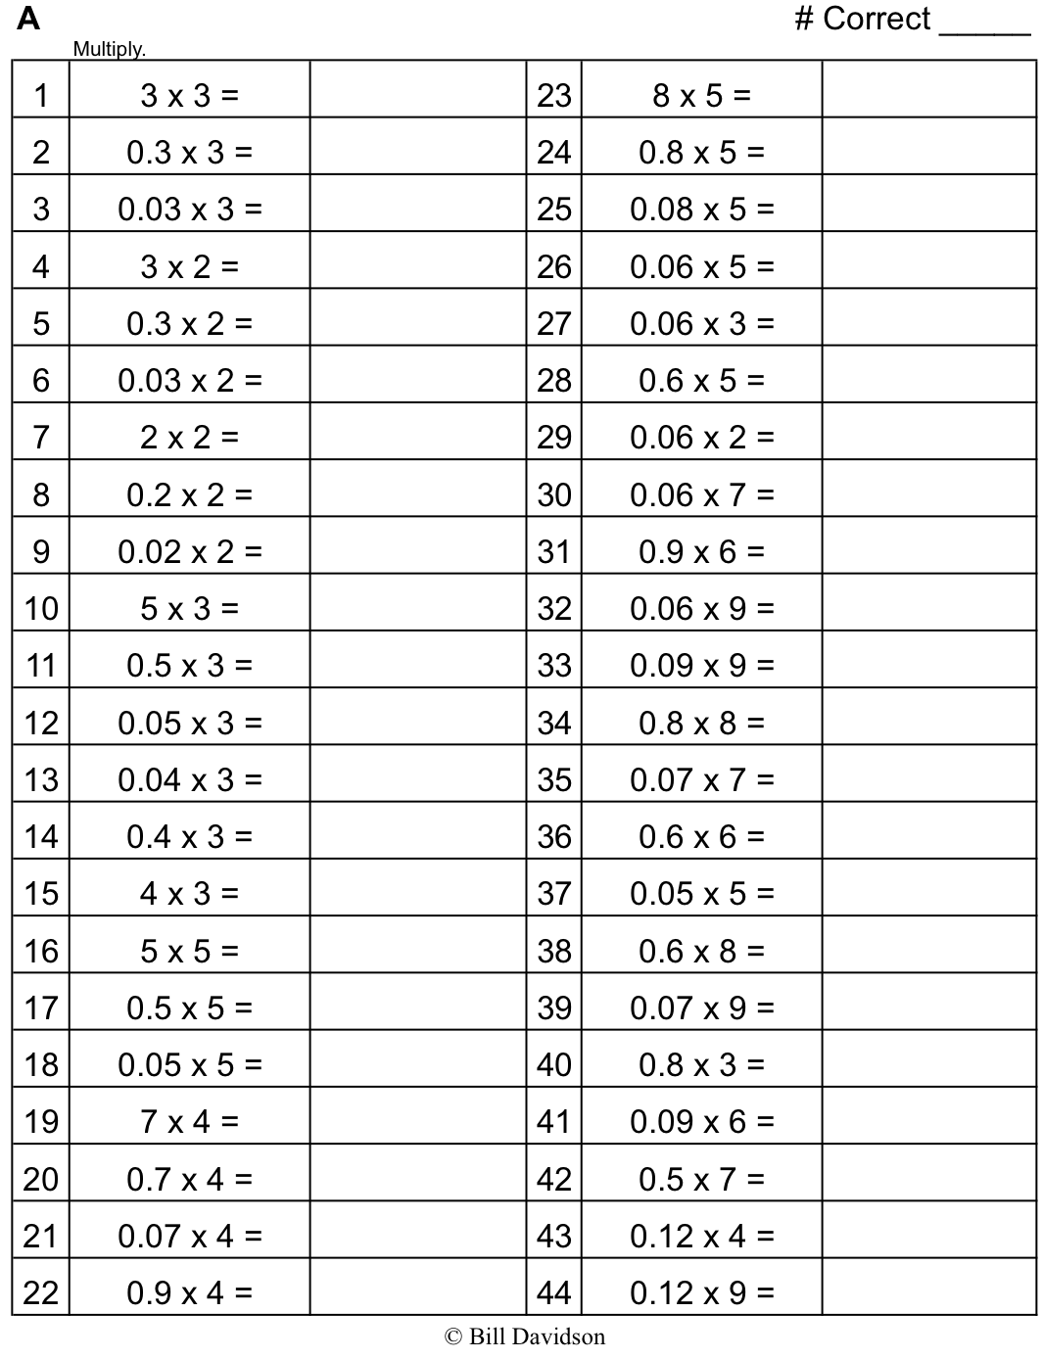

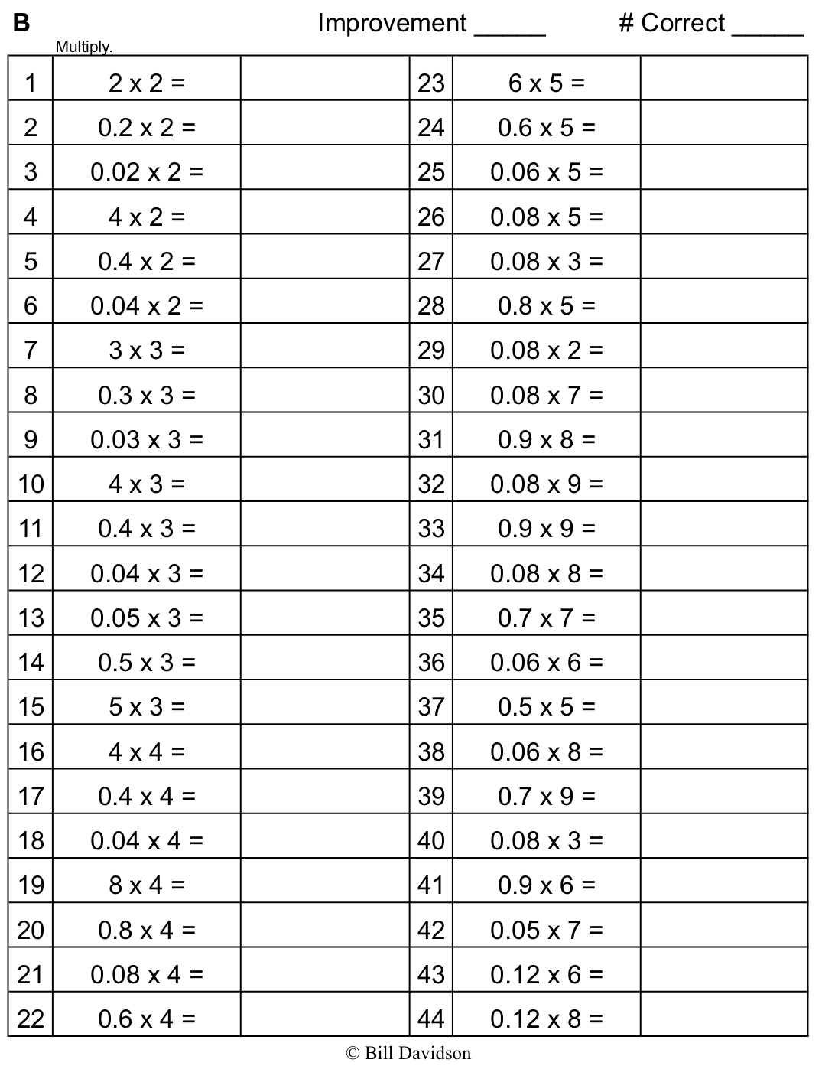

Name Date
- Estimate the product. Solve using the standard algorithm. Use the thought bubbles to show your thinking. (Draw an area model on a separate sheet if it helps you.)

- 1.38 × 32 ≈ _______ × _______ = _______ 1.38 × 32 = ______________

Think!
1.38 × 100 ÷ 138
1 . 3 8
× 3 2
Think! 4,416 is 100 times too large! What is the real product?
4,416 ÷ 100 ÷ 44.16

- 3.55 × 89 ≈ _______ × _______ = _______ 3.55 × 89 = ______________

3 . 5 5
× 8 9

Think: 138
(1.38 × 100)

- Solve using the standard algorithm.

- 5.04 × 8 b. 147.83 × 67

- 83.41 × 504 d. 0.56 × 432

- Use the whole number product and place value reasoning to place the decimal point in the second product. Explain how you know.
- If 98 × 768 = 75,264 then 98 × 7.68 = ______________

- If 73 × 1,563 = 114,099 then 73 × 15.63 = ______________

- If 46 × 1,239 = 56,994 then 46 × 123.9 = ______________

- Jenny buys 22 pens that cost $1.15 each and 15 markers that cost $2.05 each. How much did Jenny spend?

- A living room measures 24 feet by 15 feet. An adjacent square dining room measures 13 feet on each side. If carpet costs $6.98 per square foot, what is the total cost of putting carpet in both rooms?

Name Date
Use estimation and place value reasoning to find the unknown product. Explain how you know.

- If 647 × 63 = 40,761 then 6.47 × 63 =______________

- Solve using the standard algorithm.

- 6.13 × 14
- 104.35 × 34

Name Date
- Estimate the product. Solve using the standard algorithm. Use the thought bubbles to show your thinking. (Draw an area model on a separate sheet if it helps you.)

- 2.42 × 12 ≈ _______ × _______ = _______ 2.42 × 12 = ______________

Think!
2.42 × 100 ÷ 242

2. 4 2
× 1 2

Think! 2,904 is 100 times too large! What is the real product?
2,904 ÷ 100 ÷ 29.04

- 4.13 × 37 ≈ _______ × _______ = _______ 4.13 × 37 = ______________

4 . 1 3
× 3 7

- Solve using the standard algorithm.

- 2.03 × 13 b. 53.16 × 34

- 371.23 × 53 d. 1.57 × 432

- Use the whole number product and place value reasoning to place the decimal point in the second product. Explain how you know.
- If 36 × 134 = 4,824 then 36 × 1.34 = ______________

- If 84 × 2,674 = 224,616 then 84 × 26.74 = ______________

- 19 × 3,211 = 61,009 then 321.1 × 19 = ______________

- A slice of pizza costs $1.57. How much will 27 slices cost?

- A spool of ribbon holds 6.75 meters. A craft club buys 21 spools.
- What is the total cost if the ribbon sells for $2 per meter?

- If the club uses 76.54 meters to complete a project, how much ribbon will be left?

multiply decimals
multiply decimals

