Lesson 21
Objective: Divide two- and three-digit dividends by two-digit divisors with single-digit quotients and make connections to a written method.

Suggested Lesson Structure
 Fluency Practice (12 minutes)
 Application Problem (5 minutes)
 Concept Development (33 minutes)
 Student Debrief (10 minutes)
Total Time (60 minutes)
Fluency Practice (12 minutes)
- Group Count by Multi-Digit Numbers 5.NBT.6 (5 minutes)
- Divide by Two-Digit Numbers 5.NBT.6 (7 minutes)

Group Count by Multi-Digit Numbers (5 minutes)
Materials: (S) Personal white board
Note: This fluency activity prepares students for this lesson’s Concept Development.
Repeat the process from Lesson 19 for 31 and 16.

Divide by Two-Digit Numbers (7 minutes)
Materials: (S) Personal white board
Notes: This fluency activity reviews Lesson 20 content.
T: (Write 61 ÷ 17.) On your personal white boards, show me how to estimate the quotient.
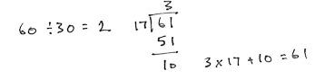
S: (Write 60 ÷ 20 = 3.)
T: Solve the equation.
S: (Solve and check as exemplified to the right.)
Repeat the process using the following possible sequence: 48 ÷ 21, 99 ÷ 32, and 74 ÷ 37.

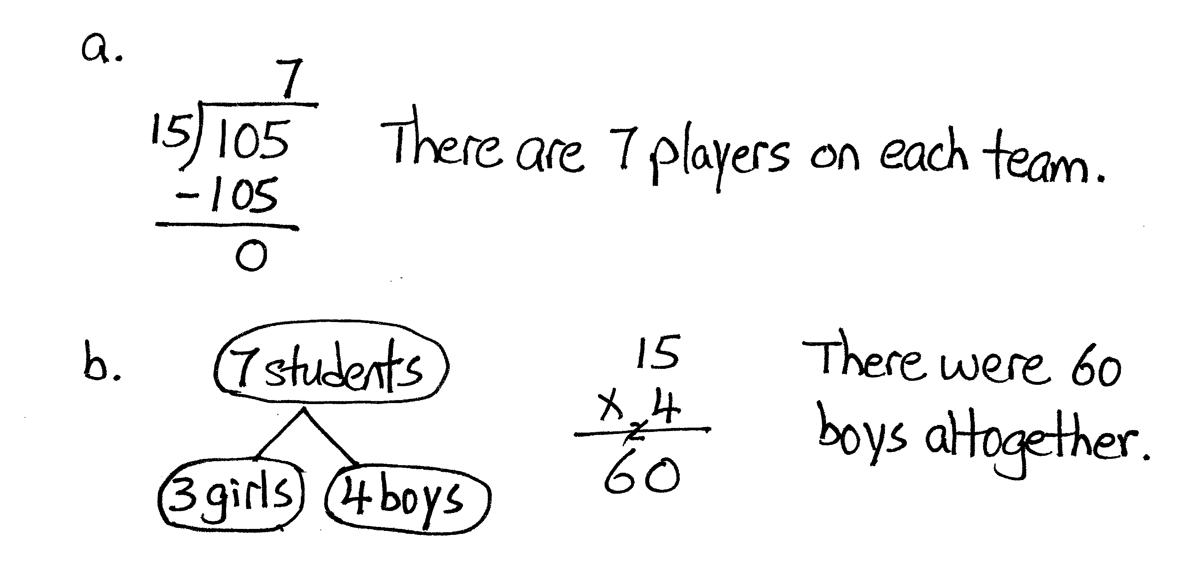
Application Problem (5 minutes)
105 students were divided equally into 15 teams.
- How many players were on each team?
- If each team had 3 girls, how many boys were there altogether?
Note: Although yesterday’s lesson focused only on two-digit totals, the friendly divisor of 15 makes this problem manageable for students. Students who have difficulty answering Part (a) may need extra support during the Concept Development.
NOTES ON
TRUE EQUATIONS:
Be careful to record work correctly.
When estimating a quotient:
Correct:
- 250 ÷ 50 = 25 ÷ 5 = 5
- 256 ÷ 47 ≈ 250 ÷ 50
Incorrect:
- 256 ÷ 47 = 250 ÷ 50 = 25 ÷ 5 = 5
- 256 ÷ 47 ≈ 250 ÷ 50 = 25 ÷5 = 5
When checking a quotient and remainder:
Correct:
- 47 × 5 + 21 = 256
Incorrect:
- 47 × 5 = 235 + 21 = 256
Concept Development (33 minutes)
Materials: (S) Personal white board
Problem 1: 256 ÷ 47
T: (Write 256 ÷ 47 horizontally on the board.) How can we estimate the quotient? Discuss with a partner.
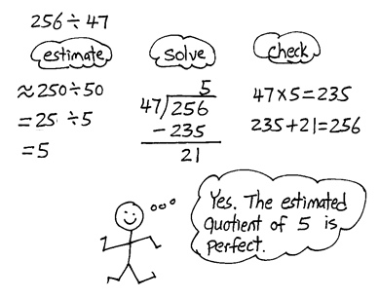
S: (Discuss.) We need a multiple of 50 that is close to 256. 250 ÷ 50 = 25 ÷ 5 = 5.
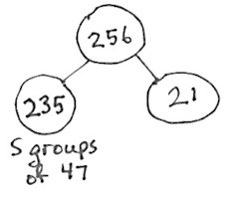
T: Let’s use the estimate to help us solve in the standard algorithm. (On the board, write and set up the standard algorithm below 256 ÷ 47.) Our estimated quotient is 5. I’ll record that. (Record the quotient 5 in the ones place above 256.) What is 5 × 47? You may solve it on your personal white board if you like.
S: 235.
T: (Record 235 below 256.) How many are remaining?
S: 21.
T: (Record 21 in the algorithm.) Do we have enough for another group of 47?
S: No.
T: So what does the 21 represent? Whisper to your neighbor.
S: This is what is left of our whole after we made all the groups of 47 we could.
T: How did our estimate help us solve?
S: It gave us a starting point for our quotient. We estimated the quotient to be 5, and our actual quotient is 5 with a remainder of 21. The estimate was just right.
T: This time our estimate did not need to be adjusted. Why do you think that is the case?
S: We estimated 47 to be 50 and the whole was almost a multiple of 50. Our divisor was smaller than 50, so we didn’t go over. Maybe if it was 54 it wouldn’t have worked so well even though it rounds to 50, too. Yes, 54 would go over! 54 times 5 is 270, which is over 256.
T: Work with a partner to check the quotient.
T: One part is 5 complete groups of 47. The other part is the 21. What’s the whole?
S: 256.
Problem 2: 236 ÷ 39
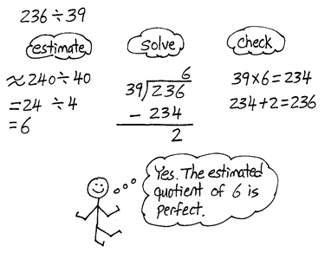
T: (Write 236 ÷ 39 horizontally on the board.) Think on your own. How will you estimate? (Give students time to think.) Tell me how you’ll estimate.
S: 240 ÷ 40 = 6.
T: What basic fact helped you to estimate?
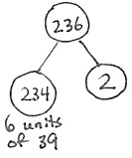
S: 24 ÷ 6 = 4.
T: On your board, solve this problem with your partner using the standard algorithm. Partner A will divide using the standard algorithm, and Partner B will check the answer.
T: Let’s go over the answer. Analyze why our estimate was perfect.
S: 39 is really close to our estimated divisor, 40. The total was less than the rounded whole but by just a little bit. It was close! 39 is one less than 40, so 6 groups of 39 will be 6 less than 240. The rounded quotient was 4 less than 240, so the difference is 2, our remainder!
T: What is 236 divided by 39?
S: The quotient is 6 with a remainder of 2.
T: Check it. How much is 39 × 6 + 2?
S: 236.
Problem 3: 369 ÷ 46
T: (Write 369 ÷ 46 horizontally on the board.) How will you estimate the quotient?
NOTES ON
MULTIPLE MEANS
OF REPRESENTATION:
Please note that there are multiple ways of recording the general method for division. Alternate ways of correcting underestimated quotients are included here. While the standard method for recording the algorithm is considered the goal in A Story of Units, some students may find these alternative recording methods more accessible.
S: 350 ÷ 50 = 7. 400 ÷ 40 = 10. 360 ÷ 40 = 9.
T: These are all reasonable estimates. Let’s use 350 ÷ 50 = (350 ÷ 10) ÷ 5 = 35 ÷ 5 = 7. (Write the estimate below the problem.)
T: (Write the problem in a vertical algorithm, and record 7 in the ones column in the quotient.) How much is 46 × 7? You may solve on your board.
S: 322.
T: Subtract this from our whole. How many ones are remaining?
S: 47. (Record – 322 and 47 in the algorithm.)
T: What do you notice about the remainder of 47 ones? Turn and discuss with your partner.
S: The remainder is larger than the group size, which means I have enough to make another group.
47 is greater than the divisor of 46. We haven’t made enough groups. We only made 7 groups of 46, but we can make 8. Since 47 is bigger than 46, it means that the quotient of 7 is not big enough. We could try to use the quotient of 8.
MP.2
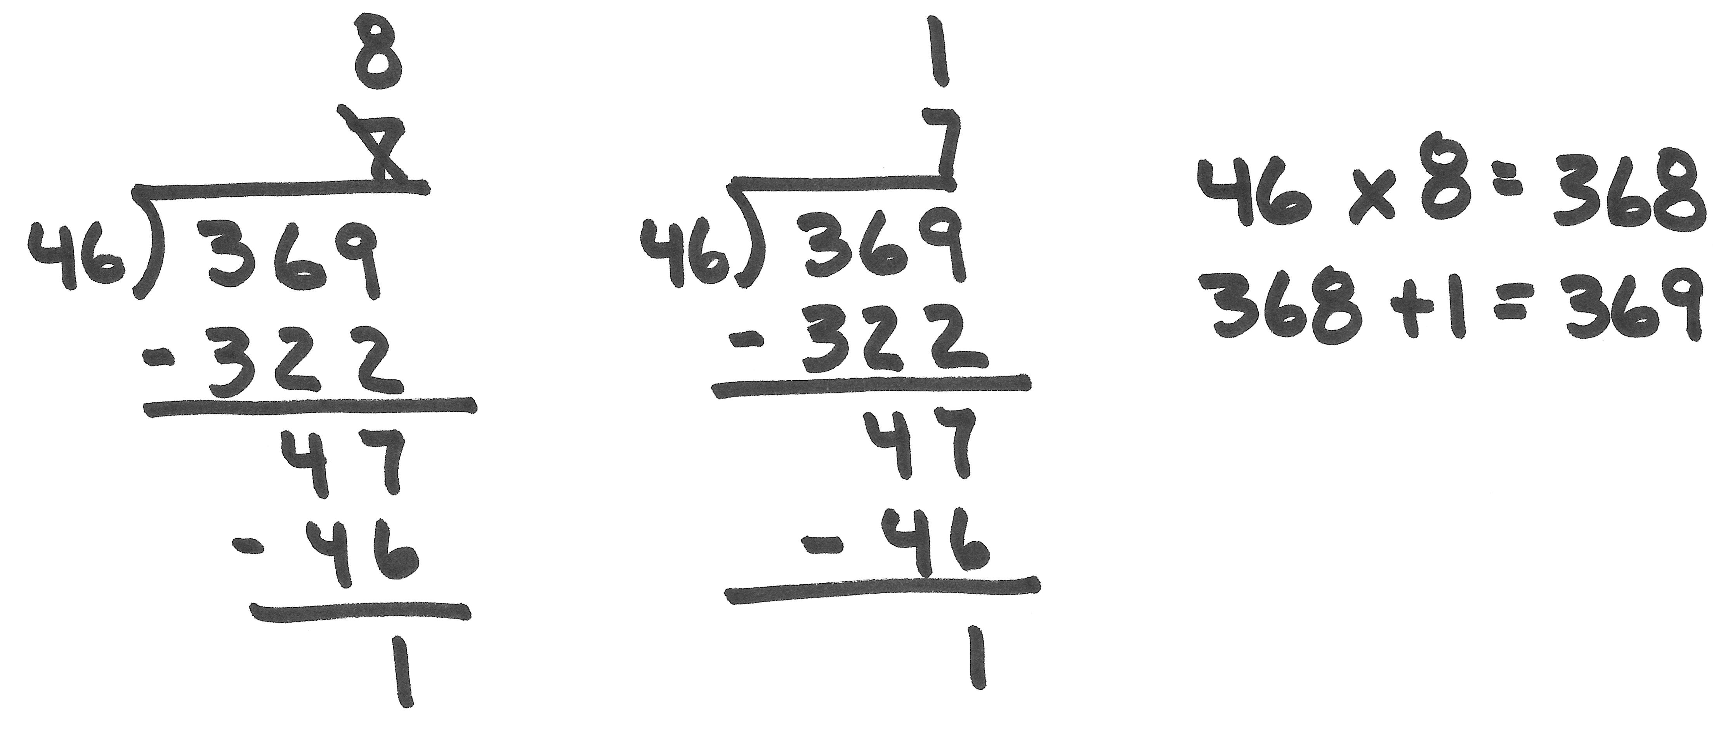
T: We have 47 remaining. We agree that’s enough to make another group of 46. We can record this several ways. (Write on board.)
- Erase, start over, and use 8 as our quotient.
- Subtract one more group of 46, cross out the 7 at the top, and write in an 8.
- Subtract one more group of 46 and record a 1 above the 7 in our vertical algorithm.
T: To state our final quotient, we will need to remember to add 7 and 1.
T: (Subtract one more unit of 46.) Now, how many are remaining?
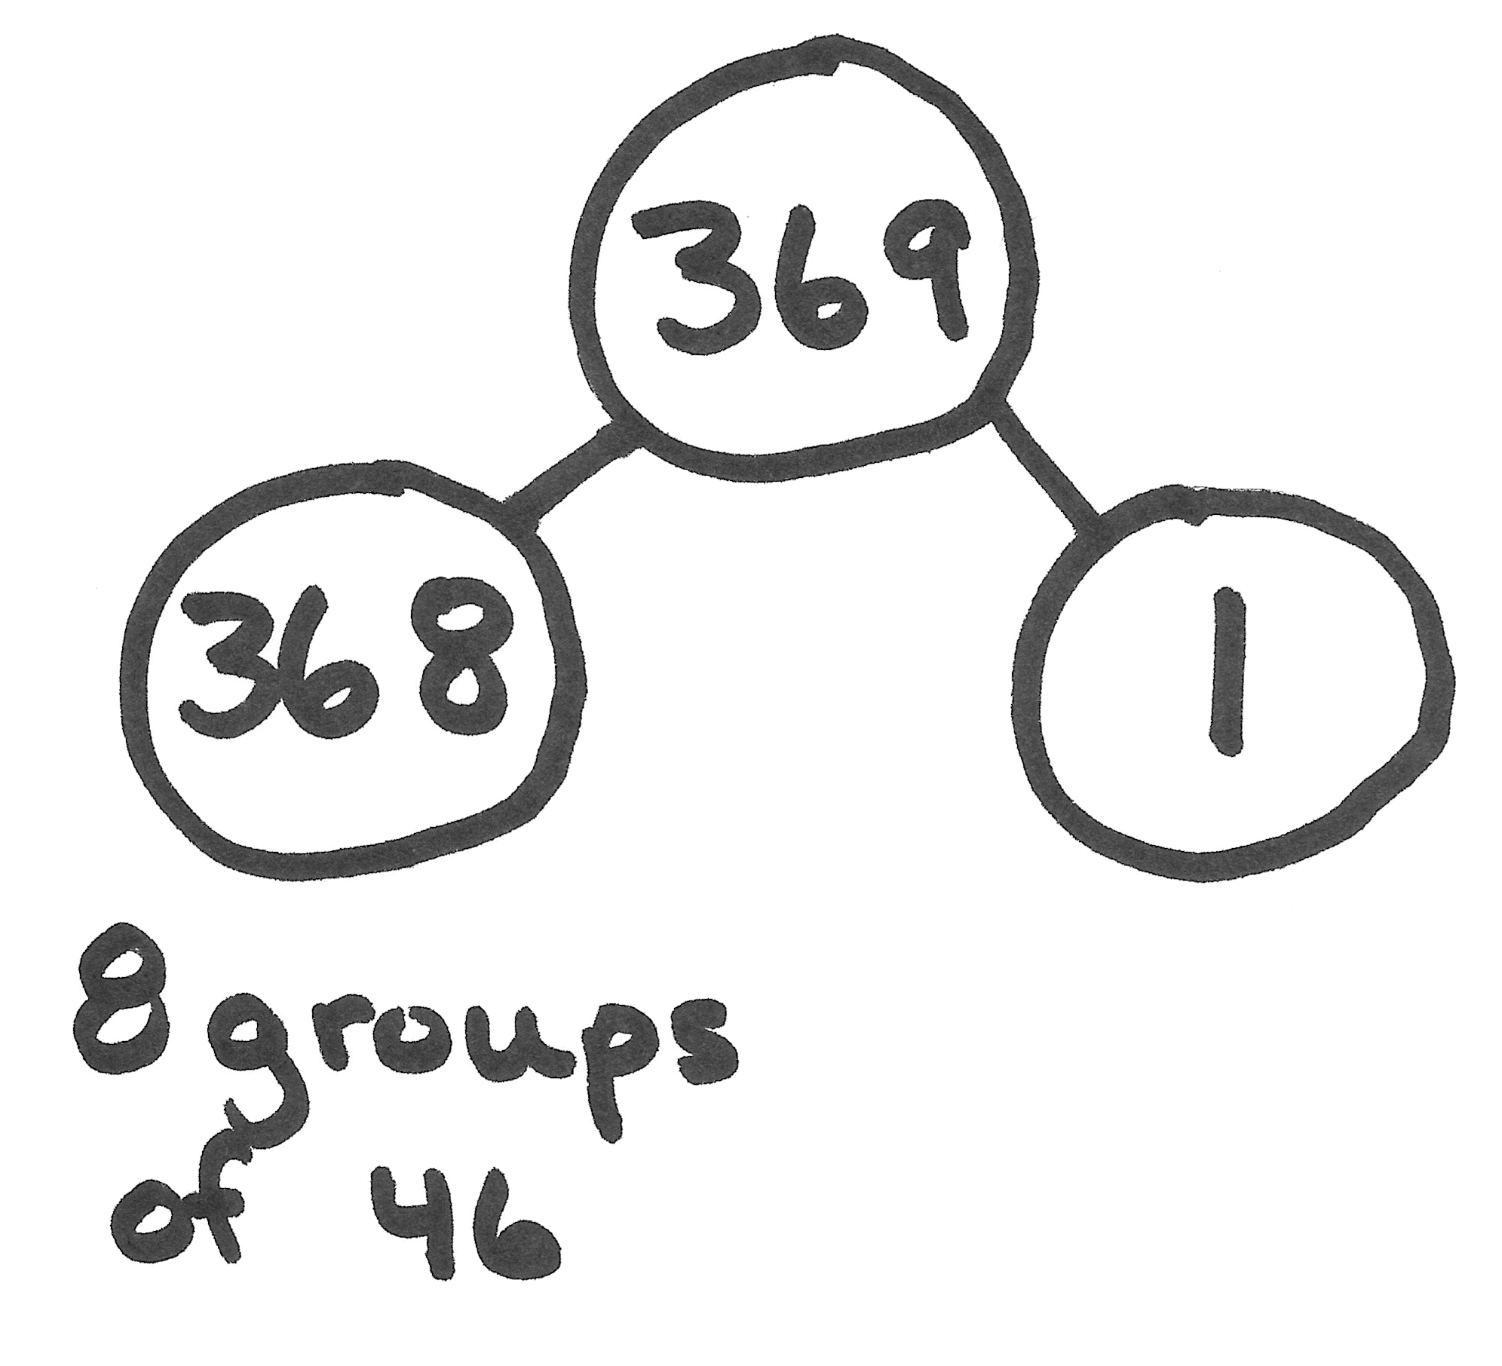
S: 1.
T: (Record this in the algorithm.) Is that enough for another group of 46?
S: No.
T: How many forty-sixes are in 369?
S: 8 units of 46 with 1 one remaining.
T: Check it. Remember that we have 8 units of 46. Solve 8 × 46 + 1? (Write the expression on the board.)
S: 369.
T: Let’s go back and look at our original estimation. If you remember, I suggested 350 ÷ 50. Turn and talk to your partner about how we ended up with a quotient that was too small.
S: Our actual divisor was a lot smaller than the estimate. If the divisor is smaller, you can make more groups. Also, our actual whole amount was bigger than our estimate. If the whole is larger, we can make more groups! So, a smaller group size and larger whole meant our estimate was too small.
T: So what can we say about estimating quotients?
S: Sometimes when we estimate a quotient, we need to be prepared to adjust it, if necessary.
Problem 4: 712 ÷ 94
T: (Write 712 ÷ 94 horizontally on the board.) Use your personal white board. Talk with your partner, and estimate the quotient.

S: 700 ÷ 100 or just 7. 720 ÷ 90, which is the same as 72 ÷ 9 = 8.
T: Both are reasonable estimates. Let’s use the estimate that divides 720 by 90. That gives us an estimated quotient of 8. (Record this estimate on the board.) Talk with your partner about this estimate. What do you notice?
S: An estimate of 8 is too much because 8 groups of 90 is already more than 712, 8 × 90 = 720. We’ll try 7 as our quotient.
T: What was your estimated quotient when you divided 700 by 10?
S: 7.
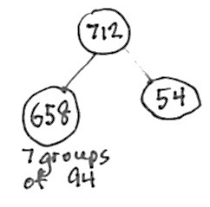
T: So, either estimate helped us get a starting place for our actual division. Even our imperfect estimate of 8 led us to the correct quotient. Now finish the division, and check on your board. When you’re finished, check it with a neighbor.
T: What’s the answer for 712 divided by 94?
S: The quotient is 7 with a reminder of 54 ones.
T: Tell me the equations that you’d use to check your answer.
S: 94 × 7 = 658 and 658 + 54 = 712.
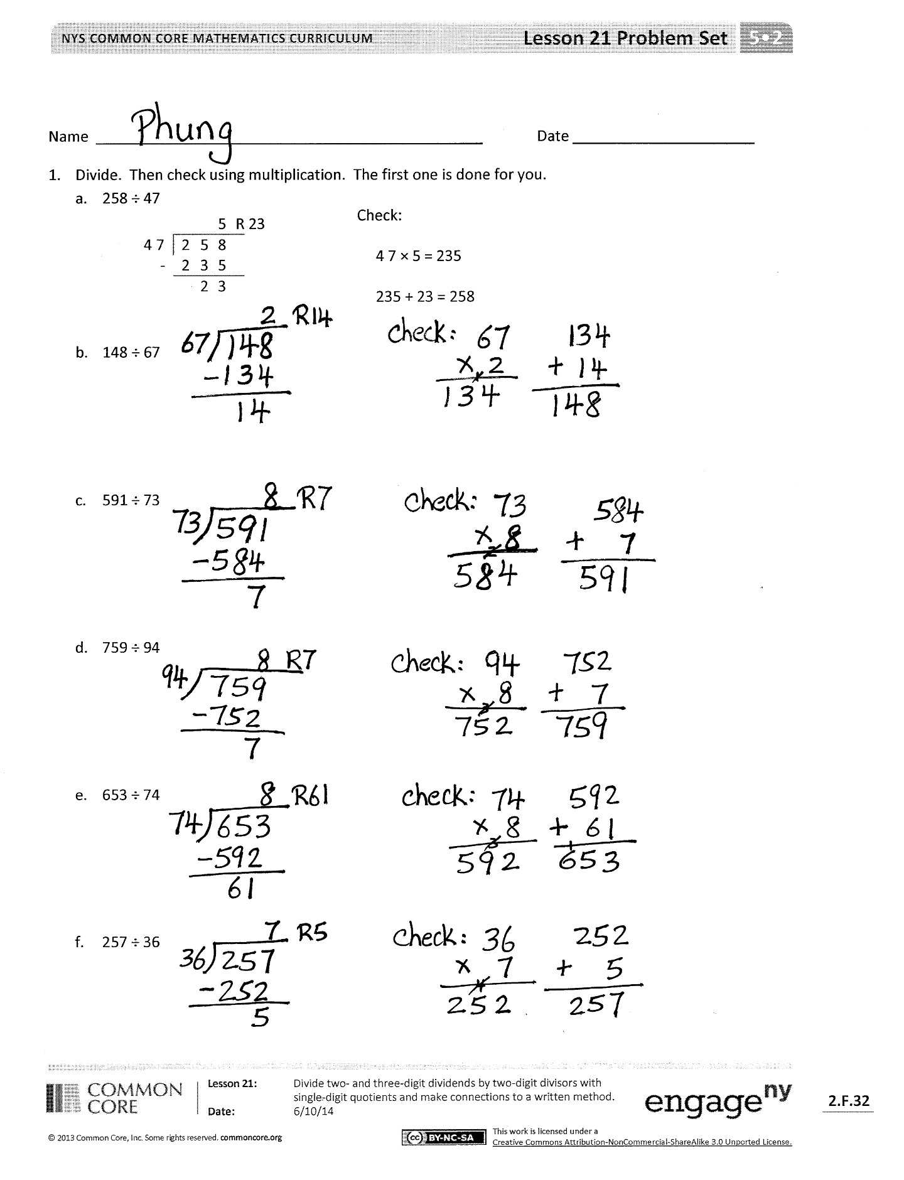
Problem Set (10 minutes)
Students should do their personal best to complete the Problem Set within the allotted 10 minutes. For some classes, it may be appropriate to modify the assignment by specifying which problems they work on first. Some problems do not specify a method for solving. Students should solve these problems using the RDW approach used for Application Problems.
Student Debrief (10 minutes)
Lesson Objective: Divide two- and three-digit dividends by two-digit divisors with single-digit quotients and make connections to a written method.
The Student Debrief is intended to invite reflection and active processing of the total lesson experience.
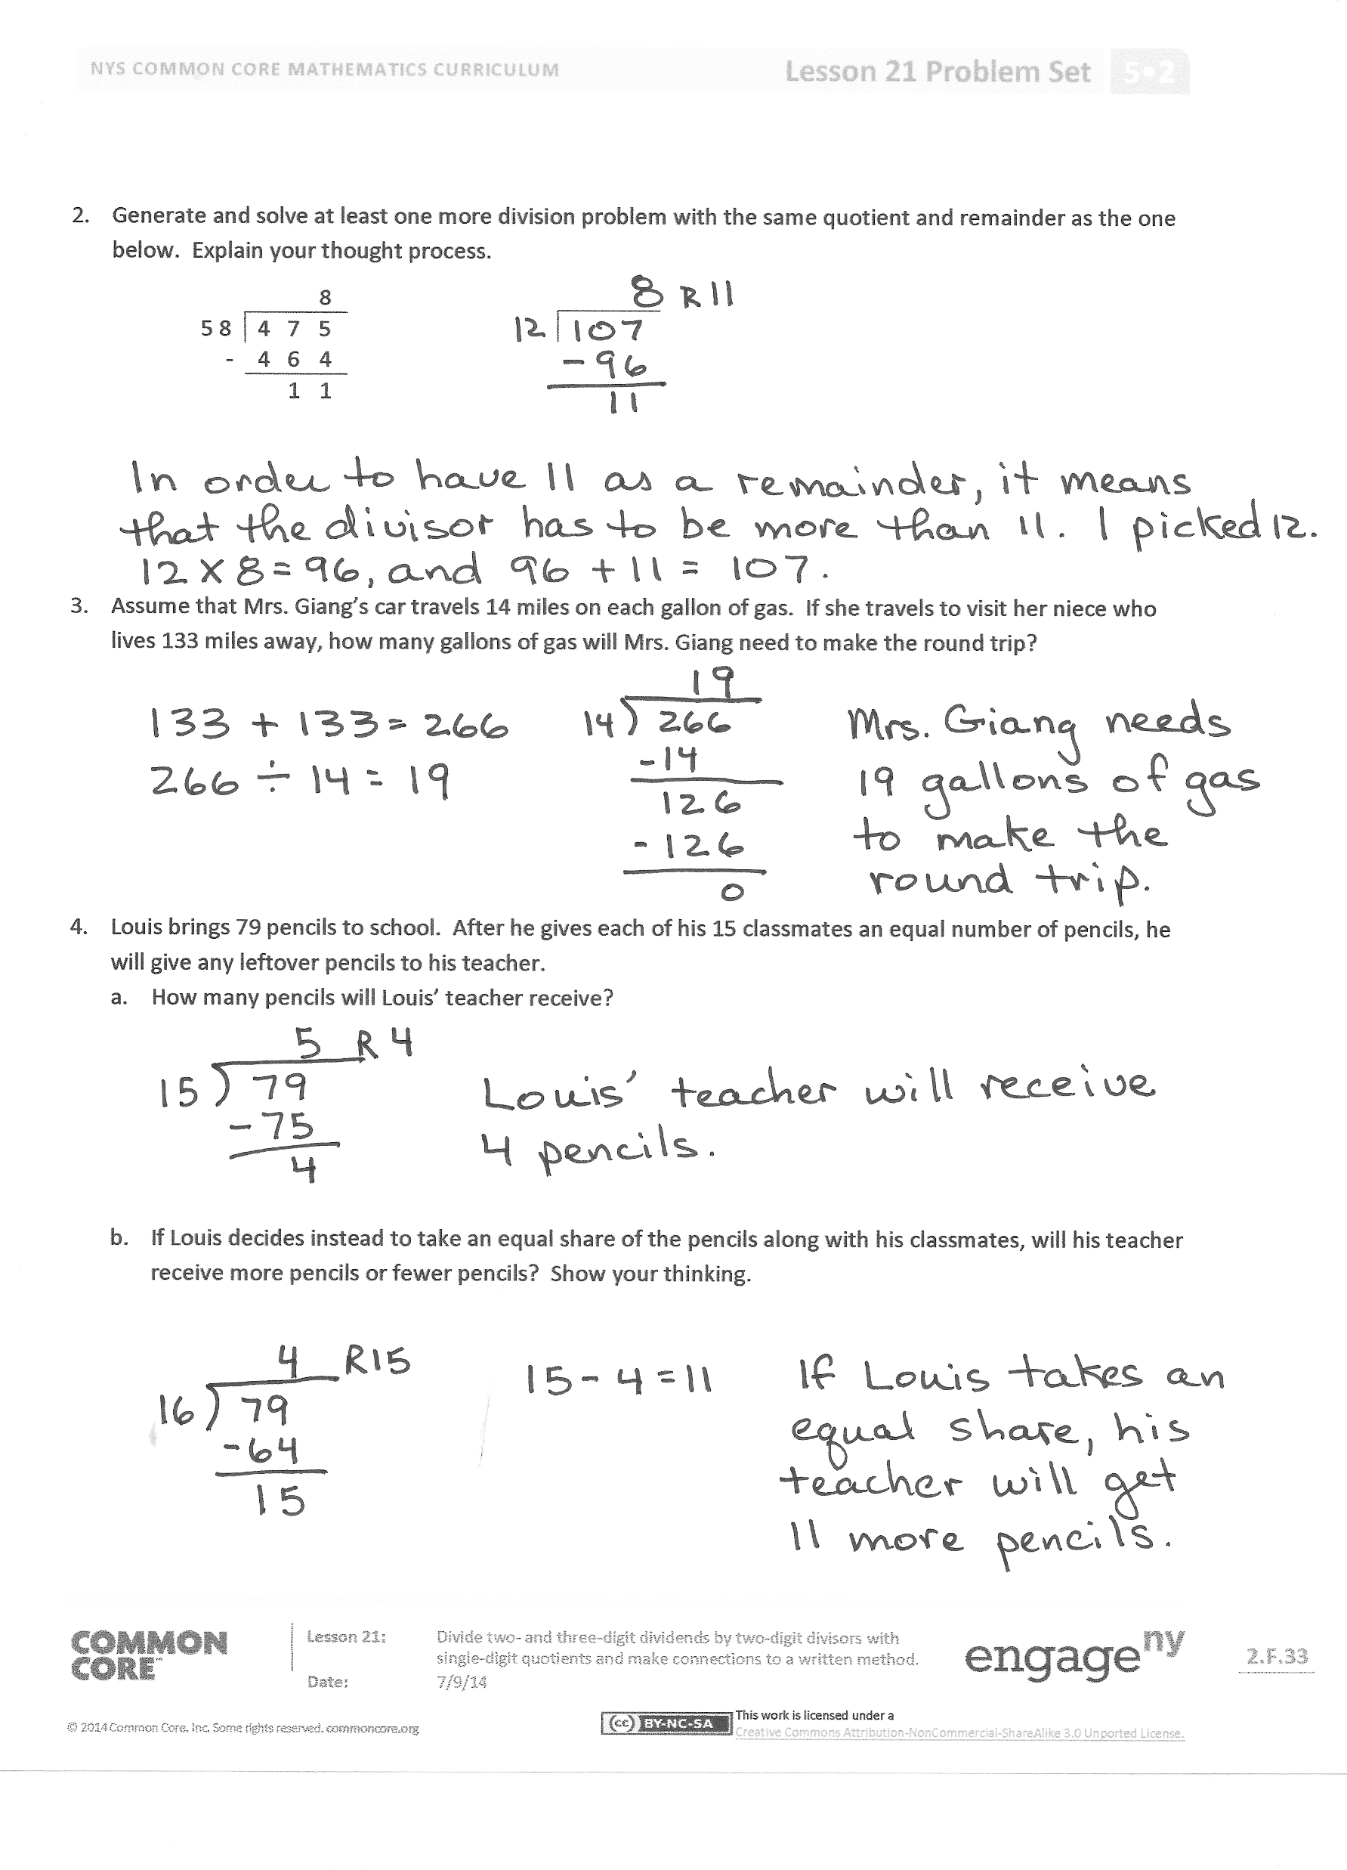
Invite students to review their solutions for the Problem Set. They should check work by comparing answers with a partner before going over answers as a class. Look for misconceptions or misunderstandings that can be addressed in the Debrief. Guide students in a conversation to debrief the Problem Set and process the lesson.
You may choose to use any combination of the questions below to lead the discussion.
- What similarity did you notice between Problems 1(c) and 1(d)? Since the quotient was 8 with remainder 7 for both problems, does that mean the two division expressions are equal to each other? Discuss the meaning of the quotient and remainder for both problems.
- In Problem 1, did your estimates need adjusting at times? When? What did you do in order to continue dividing?
- Share your thought process as you solved Problem 2. Can anyone share his or her solution? How many solutions might there be to this problem? Can you create another solution to it? How did your understanding of the check process help you answer this? Explain how the expression (n × 8) + 11 might be used to solve this problem.

- What steps did you take as you solved Problem 3? Raise your hand if you doubled the distance (since 133 miles is just one way) before dividing. Try to find a classmate who solved this problem differently from you (one who doubled the quotient after dividing, perhaps). Compare your answers. What did you find?
  - If the distance is doubled first, a quotient of 19 with no remainder is found. That is, Mrs. Giang only needs 19 gallons of gas. Solving the problem this way, however, results in a division problem with a two-digit quotient. Although finding a 2-digit quotient is taught in Lesson 22, many students will be capable of the mathematics involved.
  - If 133 (the one-way distance) is divided first, a quotient of 9 with 7 miles left to drive is found. Some students may interpret the remainder and conclude that 10 gallons is needed each way, and double to arrive at a total of 20 gallons. (This amount of fuel would certainly allow Mrs. Giang to arrive at her destination with extra gas in her tank.) This is good reasoning!
  - Students who divide first, but are thinking more deeply may realize that if the quotient (9) is doubled, then the remainder (7 miles) must also be doubled. This yields 18 gallons of gas and 14 miles left over. This additional left over 14 miles requires 1 more gallon of gas, so Mrs. Giang needs at least 19 gallons of gas.
- Discuss thoroughly the remainders in Problem 4. It might be fruitful to allow students to make a prediction about the size of the remainder in Part (b) before computing. Many students may be surprised that the teacher receives more pencils even when more students are taking pencils. Discuss how this could be possible.
- Talk about how estimating makes the process of long division more efficient.
- The estimated quotient sometimes needs to be adjusted. Talk about why this may happen.
Exit Ticket (3 minutes)
After the Student Debrief, instruct students to complete the Exit Ticket. A review of their work will help you assess the students’ understanding of the concepts that were presented in the lesson today and plan more effectively for future lessons. You may read the questions aloud to the students.

Name Date
- Divide. Then, check using multiplication. The first one is done for you.
- 258 ÷ 47
Check:

4 7 × 5 = 235

235 + 23 = 258

 |  |  |  | 5 | R 23
 | 4 7 | 2 | 5 | 8
 | - | 2 | 3 | 5
 |  |  | 2 | 3

- 148 ÷ 67

- 591 ÷ 73

- 759 ÷ 94

- 653 ÷ 74

- 257 ÷ 36

- Generate and solve at least one more division problem with the same quotient and remainder as the one below. Explain your thought process.
 |  |  |  |  | 8
 | 5 8 |  | 4 | 7 | 5
 |  | - | 4 | 6 | 4
 |  |  |  | 1 | 1

- Assume that Mrs. Giang’s car travels 14 miles on each gallon of gas. If she travels to visit her niece who lives 133 miles away, how many gallons of gas will Mrs. Giang need to make the round trip?

- Louis brings 79 pencils to school. After he gives each of his 15 classmates an equal number of pencils, he will give any leftover pencils to his teacher.
- How many pencils will Louis’ teacher receive?

- If Louis decides instead to take an equal share of the pencils along with his classmates, will his teacher receive more pencils or fewer pencils? Show your thinking.

Name Date
- Divide. Then, check using multiplication.

- 326 ÷ 53

- 192 ÷ 38
Name Date
- Divide. Then, check using multiplication. The first one is done for you.
Check:

21 × 6 = 126

126 + 3 = 129

 |  |  |  | 6 | R 3
 | 2 1 | 1 | 2 | 9
 | - | 1 | 2 | 6
 |  |  |  | 3

- 129 ÷ 21

- 158 ÷ 37

- 261÷ 49

- 574 ÷ 82

- 464 ÷ 58

- 640 ÷ 79

- It takes Juwan exactly 35 minutes by car to get to his grandmother’s. The nearest parking area is a 4-minute walk from her apartment. One week, he realized that he spent 5 hours and 12 minutes traveling to her apartment, and then back home. How many round trips did he make to visit his grandmother?

- How many eighty-fours are in 672?

