Lesson 1
Objective: Measure and compare pencil lengths to the nearest $\frac{1}{2}$, $\frac{1}{4}$, and $\frac{1}{8}$ of an inch, and analyze the data through line plots.

Suggested Lesson Structure
 Fluency Practice (11 minutes)
 Application Problem (8 minutes)
 Concept Development (31 minutes)
 Student Debrief (10 minutes)
Total Time (60 minutes)
Fluency Practice (11 minutes)
- Compare Fractions 4.NF.2 (4 minutes)
- Decompose Fractions 4.NF.3 (4 minutes)
- Equivalent Fractions 4.NF.1 (3 minutes)
Compare Fractions (4 minutes)
Materials: (S) Personal white board
Note: This fluency review prepares students for this lesson’s Concept Development.
T: (Project a tape diagram labeled as one whole and partitioned into 2 equal parts. Shade 1 of the parts.) Say the fraction.
S: 1 half.
T: (Write $\frac{1}{2}$ to the right of the tape diagram. Directly below the tape diagram, project another tape diagram partitioned into 4 equal parts. Shade 1 of the parts.) Say this fraction.
S: 1 fourth.
T: (Write $\frac{1}{2} _______\frac{1}{4}$ to the right of the tape diagrams.) On your personal white board, use the greater than, less than, or equal sign to compare.
S: (Write $\frac{1}{2} \text{>} \frac{1}{4}$.)
Continue with the following possible suggestions: $\frac{1}{2} __ \frac{1}{8 }$, $\frac{1}{8} __ \frac{1}{4}$, $\frac{1}{2} __ \frac{1}{4}$, $\frac{1}{3} __ \frac{1}{4}$, $\frac{2}{4} __ \frac{3}{6 }$, $\frac{3}{4} __ \frac{3}{8}$, $\frac{2}{5} __ \frac{2}{3}$, $\frac{3}{10} __ \frac{3}{8}$, and $\frac{2}{3} __ \frac{6}{9}$.
Decompose Fractions (4 minutes)
Materials: (S) Personal white board
Note: This fluency review prepares students for this lesson’s Concept Development.
T: (Write a number bond with $\frac{2}{3}$ as the whole and $\frac{1}{3}$ as the part.) Say the whole.
S: 2 thirds.
T: Say the given part.
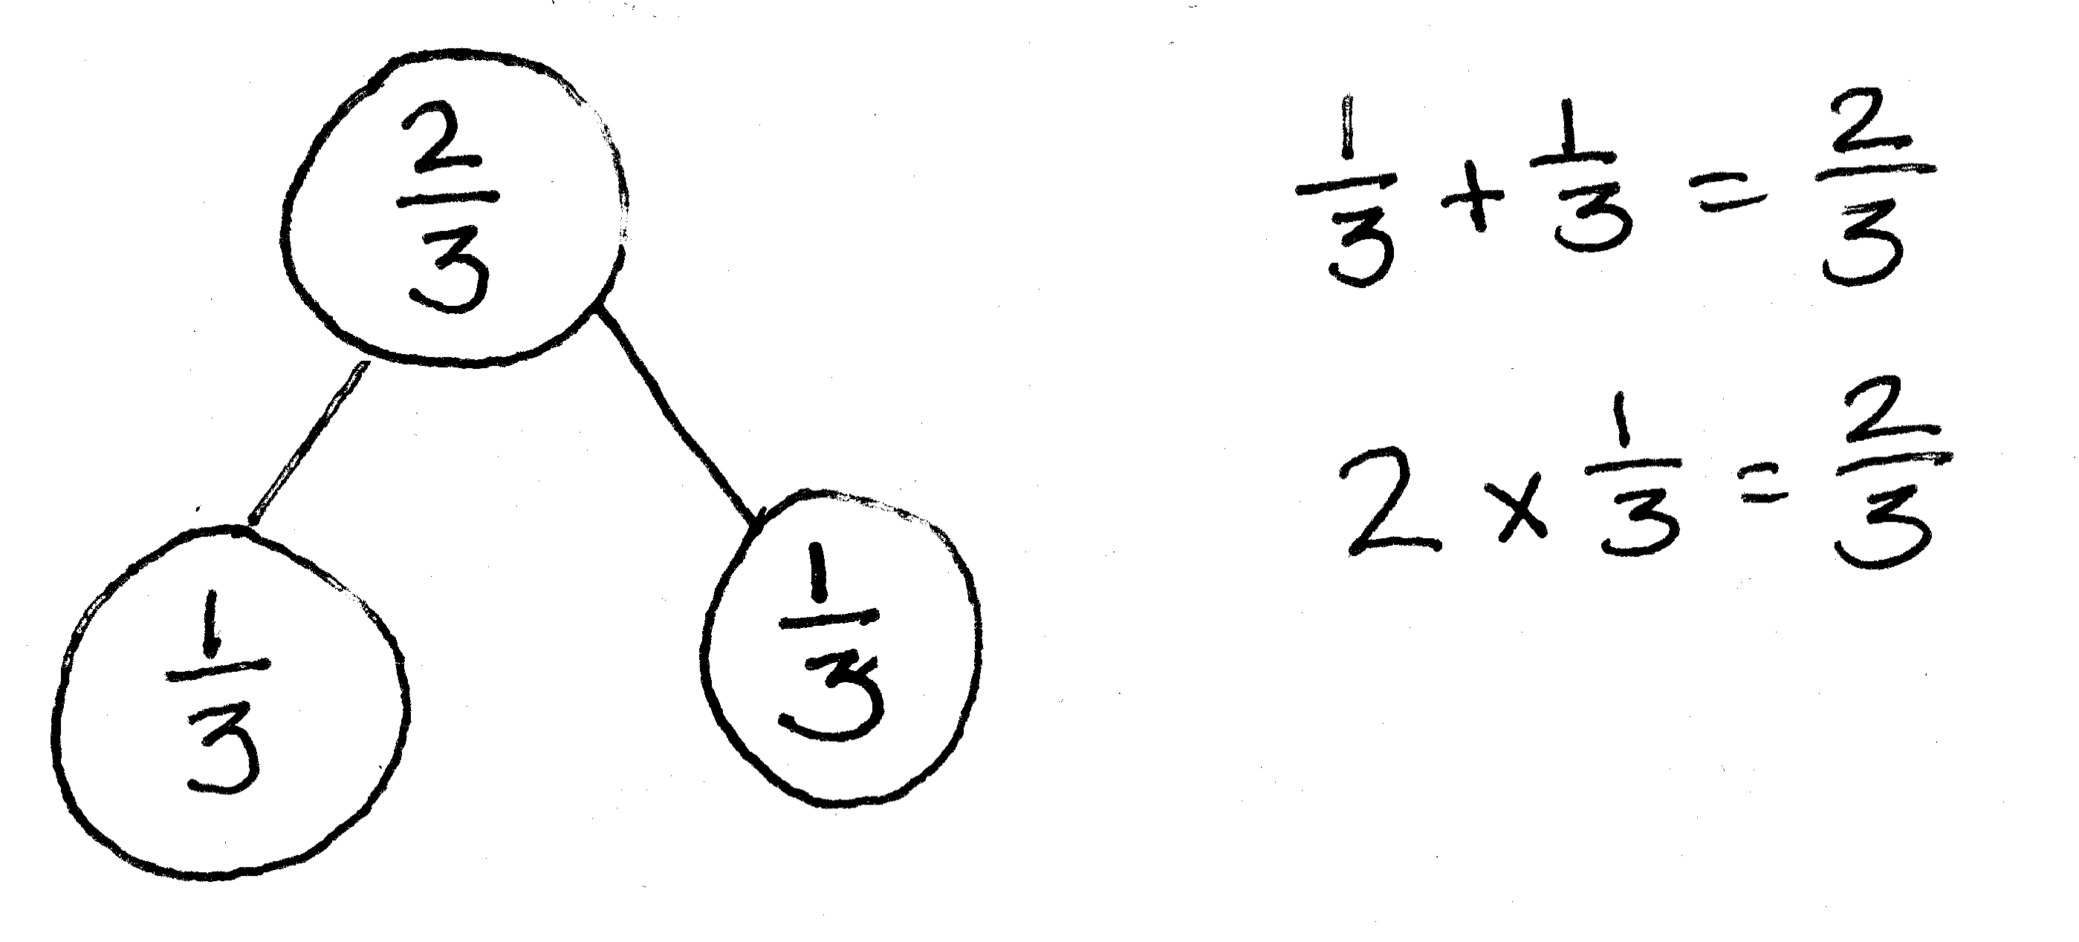
S: 1 third.
T: On your personal white boards, write the number bond. Fill in the missing part.
S: (Write $\frac{1}{3}$ as the missing part.)
T: Write an addition sentence to match the number bond.
S: $\frac{1}{3}\text{+}\frac{1}{3}\text{=}\frac{2}{3}$.
T: Write a multiplication sentence to match the number bond.
S: 2 × $\frac{1}{3}$ = $\frac{2}{3}$.
Continue with the following possible suggestions: $\frac{1}{5}\text{+} \frac{1}{5}\text{=} \frac{2}{5}$, $\frac{1}{4}\text{+} \frac{1}{4}\text{+} \frac{1}{4}\text{=} \frac{3}{4 }$, and $\frac{1}{8}\text{+} \frac{1}{8}\text{+} \frac{1}{8}\text{=} \frac{3}{8}$.
Equivalent Fractions (3 minutes)
T: (Write $\frac{1}{2}$.)
T: Say the fraction.
S: 1 half.
T: (Write $\frac{1}{2}\text{=} \frac{}{4}$.)
T: 1 half is equal to how many fourths?
S: 2 fourths.
Continue with the following possible sequence: $\frac{1}{2}\text{=} \frac{}{6},\frac{1}{3}\text{=} \frac{}{6},\frac{2}{3}\text{=} \frac{}{12},\frac{3}{4}\text{=} \frac{}{16}, \text{and}\frac{3}{5}\text{=} \frac{}{25}$.
T: (Write $\frac{1}{2}$.)
T: Say the fraction.
S: 1 half.
T: (Write $\frac{1}{2}\text{=}\frac{2}{}$.)
T: 1 half, or 1 part of 2, is the same as 2 parts of what unit?
S: Fourths.
Continue with the following possible sequence: $\frac{1}{2}\text{=}\frac{2}{},\frac{1}{5}\text{=}\frac{2}{},\frac{2}{5}\text{=}\frac{8}{},\frac{3}{4}\text{=}\frac{9}{}, \text{and} \frac{4}{5}\text{=}\frac{16}{}$.
Application Problem (8 minutes)
The following line plot shows the growth of 10 bean plants during their second week after sprouting.
Bean Growth During Week Two
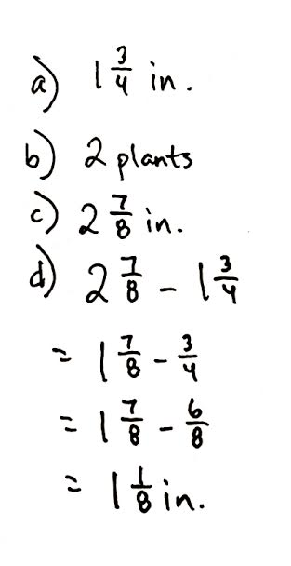
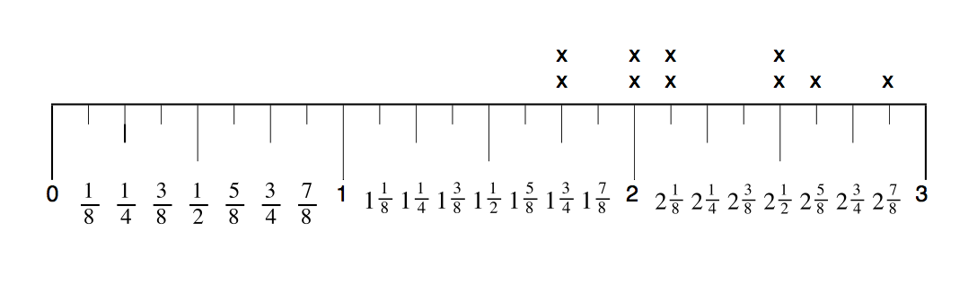

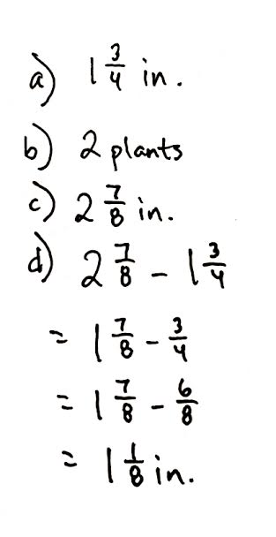

- What is the measurement of the shortest plant?
- How many plants measure$\text{2}\frac{1}{2}$ inches?
- What is the measurement of the tallest plant?
- What is the difference between the longest and shortest measurements?
Note: This Application Problem provides an opportunity for a quick, formative assessment of the student’s ability to read a customary ruler and simple line plot. Because today’s lesson is time-intensive, the analysis of this plot data is simple.
Concept Development (31 minutes)
Materials: (S) Inch ruler, Problem Set, $\text{8}\frac{\text{1}}{\text{2}}$″ × 1″ strip of paper (with straight edges) per student
Note: Before beginning the lesson, draw three number lines, one beneath the other, on the board. The lines should be marked 0–8 with increments of halves, fourths, and eighths, respectively. Leave plenty of room to position the three line plots directly beneath each other. Students will compare these line plots later during the lesson.

NOTES ON
MULTIPLE MEANS
OF REPRESENTATION:
Use colored paper for the pencil measurements to help students see where their pencil paper aligns on the rulers.

T: Cut the strip of paper so that it is the same length as your pencil.
S: (Measure and cut.)
T: Estimate the length of your pencil strip to the nearest inch and record your estimate on the first line in your Problem Set.
T: If I ask you to measure your pencil strip to the nearest half inch, what do I mean?
S: I should measure my pencil and see which half-inch or whole-inch mark is closest to the length of my strip. When I look at the ruler, I have to pay attention to the marks that split the inches into 2 equal parts, and then look for the one that is closest to the length of my strip. I know that I will give a measurement that is either a whole number or measurement with a half in it.
Discuss with students what they should do if their pencil strip is between two marks (e.g., 6 and $\text{6}\frac{1}{2}$). Remind students to round up any measurement that is more than halfway.
T: Use your ruler to measure your strip to the nearest half inch. Record your measurement by placing an X on the picture of the ruler in Problem 2 on your Problem Set.
T: Was the measurement to the nearest half inch accurate? Let’s find out. Raise your hand if your actual length was on or very close to one of the half-inch markings on your ruler.
S: (Raise hands.)
T: It seems that most of us had to round our measurement to mark it on the sheet. Let’s record everyone’s measurements on a line plot. As each person calls out his or her measurement, I’ll record the measurements on the board as you record the measurements on your Problem Set. (Poll the students.)
A typical class line plot might look similar to the following:
Class Pencil Lengths (Nearest Half Inch)

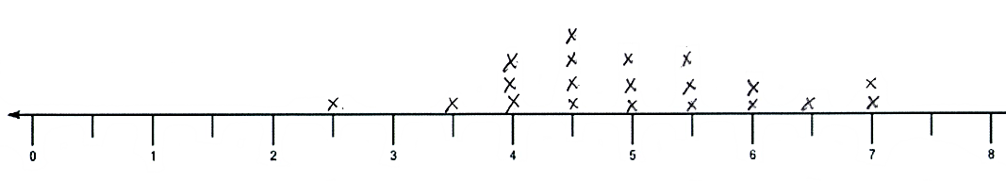

T: Which pencil measurement is the most common, or frequent, in our class? Turn and talk.
Answers will vary by class. In the plot above, $\text{4}\frac{1}{2}$ inches is most frequent.
T: Are all of the pencils used for these measurements exactly the same length? (Point to the Xs above the most frequent data point: $\text{4}\frac{1}{2}$ inches on the exemplar line plot.) Are they exactly $\text{4}\frac{1}{2}$ inches long?
S: No, these measurements are to the nearest half inch. The pencils are different sizes. We had to round the measurement of some of them. My partner and I had pencils that were different lengths, but they were close to the same mark. We had to put our marks on the same place on the sheet even though they weren’t really the same length.
MP.5
T: Now, let’s measure our strips to the nearest quarter inch. How is measuring to the quarter inch different from measuring to the half inch? Turn and talk.
S: The whole is divided into 4 equal parts instead of just 2 equal parts. Quarter inches are smaller than half inches. Measuring to the nearest quarter inch gives us more choices about where to put our Xs on the ruler.
Follow the same sequence of measuring and recording the strips to the nearest quarter inch. The line plot might look similar to the following:
Class Pencil Lengths (Nearest Quarter Inch)
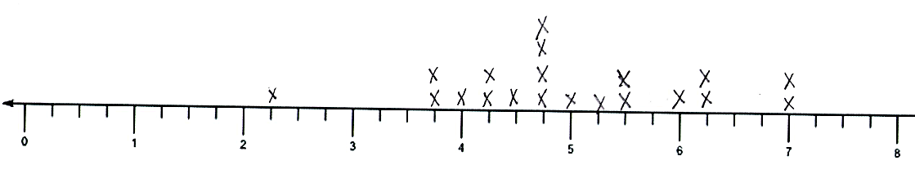

T: Which pencil measurement is the most frequent this time?
Answers will vary by class. The most frequent above is $\text{4}\frac{3}{4}$ inches.
T: If the length of our strips didn’t change, why is the most frequent measurement different this time? Turn and talk.

NOTES ON
MULTIPLE MEANS
OF REPRESENTATION:
Write math vocabulary words on sentence strips and display as they are used in context (e.g., precise, accurate).

S: The unit on the ruler we used to measure and record was different. The smaller units made it possible for me to get closer to the real length of my strip. I rounded to the nearest quarter inch, so I had to move my X to a different mark on the ruler. Other people probably had to do the same thing.
T: Yes, the ruler with smaller units (every quarter inch instead of every half inch) allowed us to be more precise with our measurement. This ruler (point to the $\frac{1}{4}$-in plot on the board) has more fractional units in a given length, which allows for a more precise measurement. It’s a bit like when we round a number by hundreds or tens. Which rounded number will be closer to the actual number? Why? Turn and talk.
S: When we round to the tens place, we can be closer to the actual number because we are using smaller units.
T: That's exactly what's happening here when we measure to the nearest quarter inch versus the nearest half inch. How did your measurements change or not change?
S: My first was 4 inches, but my second was closer to 4 and a quarter inches. My first measurement was 4 and a half inches. My second was 4 and 2 quarter inches, but that’s the same as 4 and a half inches. When I measured with the half-inch ruler, my first was closer to 4 inches than 3 and a half inches, but when I measured with the fourth-inch ruler, it was closer to 3 and 3 quarter inches. This was because it was a little closer to 3 and 3 quarter inches than 4 inches.
T: Our next task is to measure our strips to the nearest eighth of an inch and record our data in a third line plot. Look at the first two line plots. What do you think the shape of the third line plot will look like? Turn and talk.
S: The line plot will be flatter than the first two. There are more choices for our measurements on the ruler, so I think that there will be more places where there will only be one X compared to the other line plots. The eighth-inch ruler will show the differences between pencil lengths more than the half-inch or fourth-inch rulers.
Follow a similar sequence for measuring and recording this line plot.
T: Let’s find out how accurate our measurements are. Raise your hand if your actual strip length was on or very close to one of the eighth-inch markings on the ruler. (It is likely that many more students will raise their hands than before.)
S: (Raise hands.)
T: Work with your partner to answer Problem 5 on your Problem Set.
Recording the line plots on the board for later analysis with your class is highly recommended.

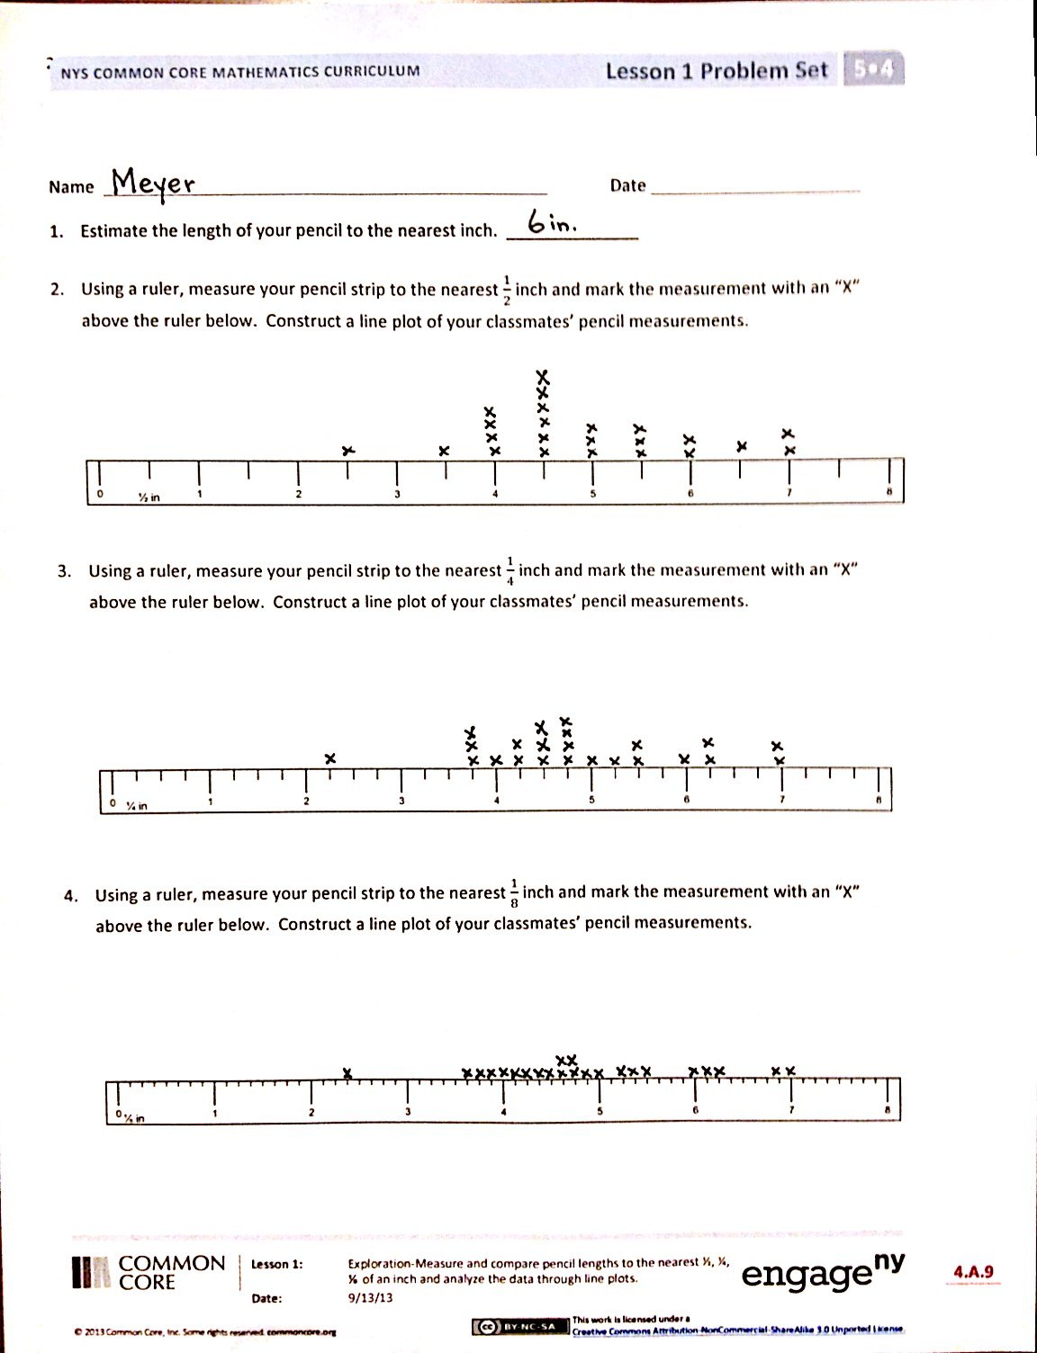
Problem Set (10 minutes)
Students should do their personal best to complete the Problem Set within the allotted 10 minutes. Some problems do not specify a method for solving. This is an intentional reduction of scaffolding that invokes MP.5, Use Appropriate Tools Strategically. Students should solve these problems using the RDW approach used for Application Problems. For some classes, it may be appropriate to modify the assignment by specifying which problems students should work on first. With this option, let the purposeful sequencing of the Problem Set guide your selections so that problems continue to be scaffolded. Balance word problems with other problem types to ensure a range of practice. Consider assigning incomplete problems for homework or at another time during the day.
Student Debrief (10 minutes)
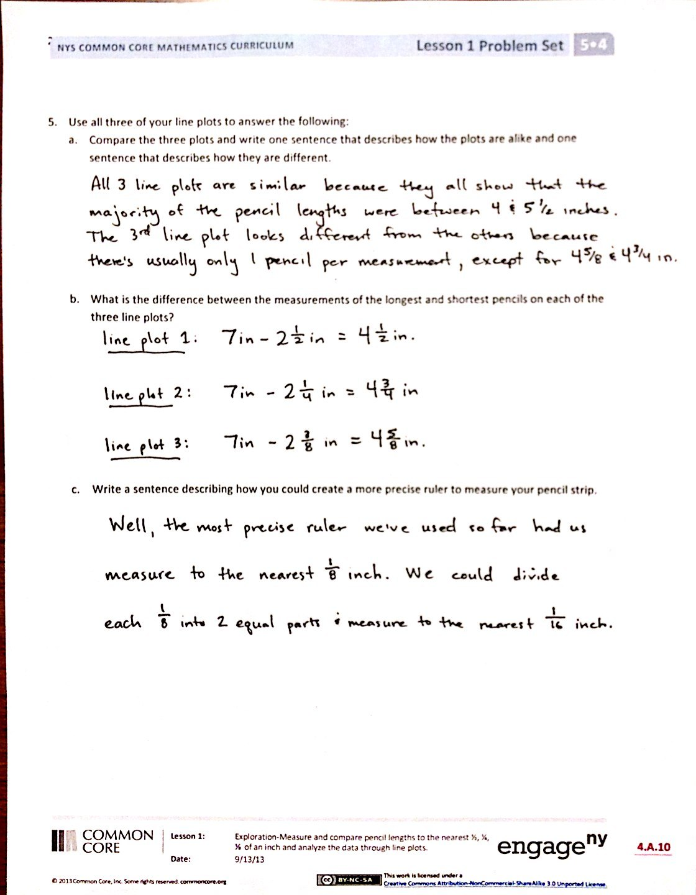
Lesson Objective: Measure and compare pencil lengths to the nearest $\frac{1}{2}$, $\frac{1}{4}$, and $\frac{1}{8}$ of an inch, and analyze the data through line plots.
The Student Debrief is intended to invite reflection and active processing of the total lesson experience.
Invite students to review their solutions for the Problem Set. They should check work by comparing answers with a partner before going over answers as a class. Look for misconceptions or misunderstandings that can be addressed in the Debrief. Guide students in a conversation to debrief the Problem Set and process the lesson.
You may choose to use any combination of the questions below to lead the discussion. However, it is recommended that the first bullet be a focus for this lesson’s discussion.
- How many of you had a pencil length that didn’t fall directly on an inch, half-inch, quarter-inch, or eighth-inch marking?
  - If you wanted a more precise measurement of your pencil’s length, what could you do? (Guide students to see that they could choose smaller fractional units.)
  - When someone tells you, “My pencil is 5 and 3 quarters inches long,” is it reasonable to assume that his or her pencil is exactly that long? (Guide students to see that, in practice, all measurements are approximations, even when assuming they are exact for the sake of calculation.)
- How does the most frequent pencil length change with each line plot? How does the number of each pencil length for each data point change with each line plot? Which line plot had the most repeated lengths? Which had the fewest repeated lengths?
- What is the effect of changing the precision of the ruler? What happens when you split the wholes on the ruler into smaller and smaller units?
- If you only know the data from the second line plot, can you reconstruct the first line plot? (No. An X at $\text{3}\frac{3}{4}$ inches on the second line plot could represent a pencil as short as $\text{3}\frac{1}{2}$ inches or as long as 4 inches in the first line plot. However, if an X is on a half-inch mark—3, $\text{3}\frac{1}{2}$, 4, $\text{4}\frac{1}{2}$, etc.,—on the second line plot, then we know that it is at the same half-inch mark in the first line plot.)
- Can the first line plot be completely reconstructed knowing only the data from the third line plot? (Generally, no. However, more of the first line plot can be reconstructed from the third line plot rather than the second line plot.)
- The following can accommodate high-performing students: Which points on the third line plot can be used, and which ones cannot be used to reconstruct the first line plot?
- Which line plot contains the most accurate measurements? Why? Why are smaller units generally more accurate?
- Are smaller units always the better choice when measuring? (Guide students to see that different applications require varying degrees of accuracy. Smaller units allow for greater accuracy, but greater accuracy is not always required.)
Exit Ticket (3 minutes)
After the Student Debrief, instruct students to complete the Exit Ticket. A review of their work will help you assess the students’ understanding of the concepts that were presented in the lesson today and plan more effectively for future lessons. You may read the questions aloud to the students.

Name Date
- Estimate the length of your pencil to the nearest inch. ______________

- Using a ruler, measure your pencil strip to the nearest $\frac{1}{2}$ inch and mark the measurement with an X above the ruler below. Construct a line plot of your classmates’ pencil measurements.

- Using a ruler, measure your pencil strip to the nearest $\frac{1}{4}$ inch and mark the measurement with an X above the ruler below. Construct a line plot of your classmates’ pencil measurements.

- Using a ruler, measure your pencil strip to the nearest $\frac{1}{8}$ inch and mark the measurement with an X above the ruler below. Construct a line plot of your classmates’ pencil measurements.

- Use all three of your line plots to complete the following.
  - Compare the three plots, and write one sentence that describes how the plots are alike and one sentence that describes how they are different.

  - What is the difference between the measurements of the longest and shortest pencils on each of the three line plots?

  - Write a sentence describing how you could create a more precise ruler to measure your pencil strip.

Name Date
- Draw a line plot for the following data measured in inches:
$\text{1}\frac{\text{1}}{\text{2}}\text{, 2}\frac{\text{3}}{\text{4}}\text{, 3, 2}\frac{\text{3}}{\text{4}}\text{, 2}\frac{\text{1}}{\text{2}}\text{, 2}\frac{\text{3}}{\text{4}}\text{, 3}\frac{\text{3}}{\text{4}}\text{, 3, 3}\frac{\text{1}}{\text{2}}\text{, 2}\frac{\text{1}}{\text{2}}\text{, 3}\frac{\text{1}}{\text{2}}$

2. Explain how you decided to divide your wholes into fractional parts and how you decided where your number scale should begin and end.

Name Date
A meteorologist set up rain gauges at various locations around a city and recorded the rainfall amounts in the table below. Use the data in the table to create a line plot using $\frac{1}{8}$ inches.

Location | Rainfall Amount  (inches)
1 | $$\frac{\text{1}}{\text{8}}$$
2 | $$\frac{\text{3}}{\text{8}}$$
3 | $$\frac{\text{3}}{\text{4}}$$
4 | $$\frac{\text{3}}{\text{4}}$$
5 | $$\frac{\text{1}}{\text{4}}$$
6 | $$\text{1}\frac{\text{1}}{\text{4}}$$
7 | $$\frac{\text{1}}{\text{8}}$$
8 | $$\frac{\text{1}}{\text{4}}$$
9 | $\text{1}$
10 | $$\frac{\text{1}}{\text{8}}$$

- Which location received the most rainfall?

- Which location received the least rainfall?

- Which rainfall measurement was the most frequent?

- What is the total rainfall in inches?

