Lesson 2
Objective: Interpret a fraction as division.

Suggested Lesson Structure
 Application Problem (8 minutes)
 Fluency Practice (12 minutes)
 Concept Development (30 minutes)
 Student Debrief (10 minutes)
Total Time (60 minutes)
Application Problem (8 minutes)
The line plot shows the number of miles run by Noland in his PE class last month, which is rounded to the nearest quarter mile.
X
X X
X X X
X X X X

0 $\frac{1}{4}$ $\frac{1}{2}$ $\frac{3}{4}$ 1

(miles)
- If Noland ran once a day, how many days did he run?
- How many miles did Noland run altogether last month?
- Look at the circled data point. The actual distance Noland ran that day was at least ____ mile and less than ____ mile.
Note: This Application Problem reinforces the work of the previous lesson. Part (c) provides an extension for early finishers.

Fluency Practice (12 minutes)
- Factors of 100 4.NF.5 (2 minutes)
- Compare Fractions 4.NF.2 (4 minutes)
- Decompose Fractions 4.NF.3 (3 minutes)
- Divide with Remainders 5.NF.3 (3 minutes)
Factors of 100 (2 minutes)
Note: This fluency activity prepares students for fractions with denominators of 4, 20, 25, and 50 in Topic G.
T: (Write 50 × ____ = 100.) Say the equation filling in the missing factor.
S: 50 × 2 = 100.
Continue with the following possible sequence: 25 × ____ = 100, 4 × ____ = 100, 20 × ____ = 100, and
50 × ____ = 100.
T: I’m going to say a factor of 100. You say the other factor that will make 100.
T: 20.
S: 5.
Continue with the following possible sequence: 25, 50, 5, 10, and 4.
Compare Fractions (4 minutes)
Materials: (S) Personal white board
Note: This fluency activity reviews concepts from Grade 4 and G5─M3.

NOTES ON
MULTIPLE MEANS
OF REPRESENTATION:
For English language learners or students who must review the relative size of fractional units, folding square paper into various units of halves, thirds, fourths, and eighths can be beneficial. Allow students time to fold, cut, label, and compare the units in relation to the whole and each other.

T: (Project a tape diagram partitioned into 2 equal parts. Shade 1 of the parts.) Say the fraction.
S: 1 half.
T: (Write $\frac{1}{2}$ to the right of the tape diagram. Directly below the first tape diagram, project another tape diagram partitioned into 4 equal parts. Shade 3 of the parts.) Say this fraction.
S: 3 fourths.
T: What’s a common unit that we could use to compare these fractions?
S: Fourths. Eighths. Twelfths.

T: Let’s use fourths. (Below the tape, write $\frac{1}{2 }$ ____ $\frac{3}{4 }$ and $\frac{}{4}_____\frac{3}{4}$.) On your personal white board, write in the unknown numerator and a greater than or less than symbol.
S: (Write $\frac{2}{4}<\frac{3}{4}$.)
Continue with, and compare, the following possible sequence: $\frac{1}{2 }$ and $\frac{3}{8 }$, $\frac{5}{8 }$ and $\frac{1}{2}$, $\frac{5}{8 }$ and $\frac{3}{4 }$ , and $\frac{3}{4 }$ and $\frac{7}{8}$.
Decompose Fractions (3 minutes)
Materials: (S) Personal white board
Note: This fluency activity reviews concepts from Grade 4 and G5─M3.
T: (Write a number bond with $\frac{3}{5}$ as the whole and 3 missing parts.) On your personal white board, break apart 3 fifths into unit fractions.
S: (Write $\frac{1}{5}$ for each missing part.)
T: Say the multiplication equation for this bond.
S: 3 × $\frac{1}{5}$ = $\frac{3}{5}$.
Continue with the following possible sequence: $\frac{2}{3 }$, $\frac{3}{10}$, and $\frac{5}{8}$.
Divide with Remainders (3 minutes)
Materials: (S) Personal white board
Note: This fluency activity prepares students for this lesson’s Concept Development.
T: (Write 8 ÷ 2 = ____.) Say the quotient.
S: 4.
T: Say the remainder.
S: There isn’t one. 0.
T: (Write 9 ÷ 2 = ____.) Quotient?
S: 4.
T: Remainder?
S: 1.
Continue with the following possible sequence: 25 ÷ 5, 27 ÷ 5, 9 ÷ 3, 10 ÷ 3, 16 ÷ 4, 19 ÷ 4, 12 ÷ 6, and
11 ÷ 6.

Concept Development (30 minutes)
Materials: (S) Personal white board, 15 square pieces of paper per pair of students
Problem 1
2 ÷ 2
1 ÷ 2
1 ÷ 3
2 ÷ 3
T: Imagine we have 2 crackers. Use two pieces of your paper to represent the crackers. Share the crackers equally between 2 people.
S: (Distribute 1 cracker per person.)
T: How many crackers did each person get?
S: 1 cracker.
T: Say a division sentence that tells what you just did with the crackers.
S: 2 ÷ 2 = 1.
T: I’ll record that with a drawing. (Draw the 2 ÷ 2 = 1 image on the board.)
T: Now, imagine that there is only 1 cracker to share between 2 people. Use your paper and scissors to show how you would share the cracker.
MP.4
S: (Cut paper into halves.)
T: How much will each person get?
S: 1 half of a cracker.
T: Work with your partner to write a number sentence that shows how you shared the cracker equally.
S: 1 ÷ 2 = $\frac{1}{2}$. $\frac{2}{2}$ ÷ 2 = $\frac{1}{2}$. 2 halves ÷ 2 = 1 half.
T: I’ll record your thinking on the board with another drawing. (Draw the
1 ÷ 2 model, and write the number sentence beneath it.)
Repeat this sequence with 1 ÷ 3.
T: (Point to both division sentences on the board.) Look at these two number sentences. What do you notice? Turn and talk.
S: Both problems start with 1 whole, but it gets divided into 2 parts in the first problem and 3 parts in the second one. I noticed that both of the answers are fractions, and the fractions have the same digits in them as the division expressions. When you share the same size whole with 2 people, you get more than when you share it with 3 people. The fraction looks a lot like the division expression, but it’s the amount that each person receives out of the whole.

T: (Point to the number sentences.) We can write the division expression as a fraction. 1 divided by 2 is the same as 1 half. 1 divided by 3 is the same as 1 third.
T: Let’s consider sharing 2 crackers with 3 people. Thinking about 1 divided by 3, how much do you think each person would receive? Turn and talk.

NOTES ON
MULTIPLE MEANS
OF EXPRESSION:
Students with fine motor deficits may find the folding and cutting of the concrete materials difficult. Consider allowing them to serve as reporter for their learning group to share the findings, or allowing them to use online virtual manipulatives.

S: It’s double the amount of crackers shared with the same number of people. Each person should receive twice as much as before, so they should receive 2 thirds. The division sentence can be written similarly to a fraction, so 2 divided by 3 would be the same as 2 thirds.
T: Use your materials to show how you would share 2 crackers with 3 people.
S: (Work.)
Problem 2
3 ÷ 2
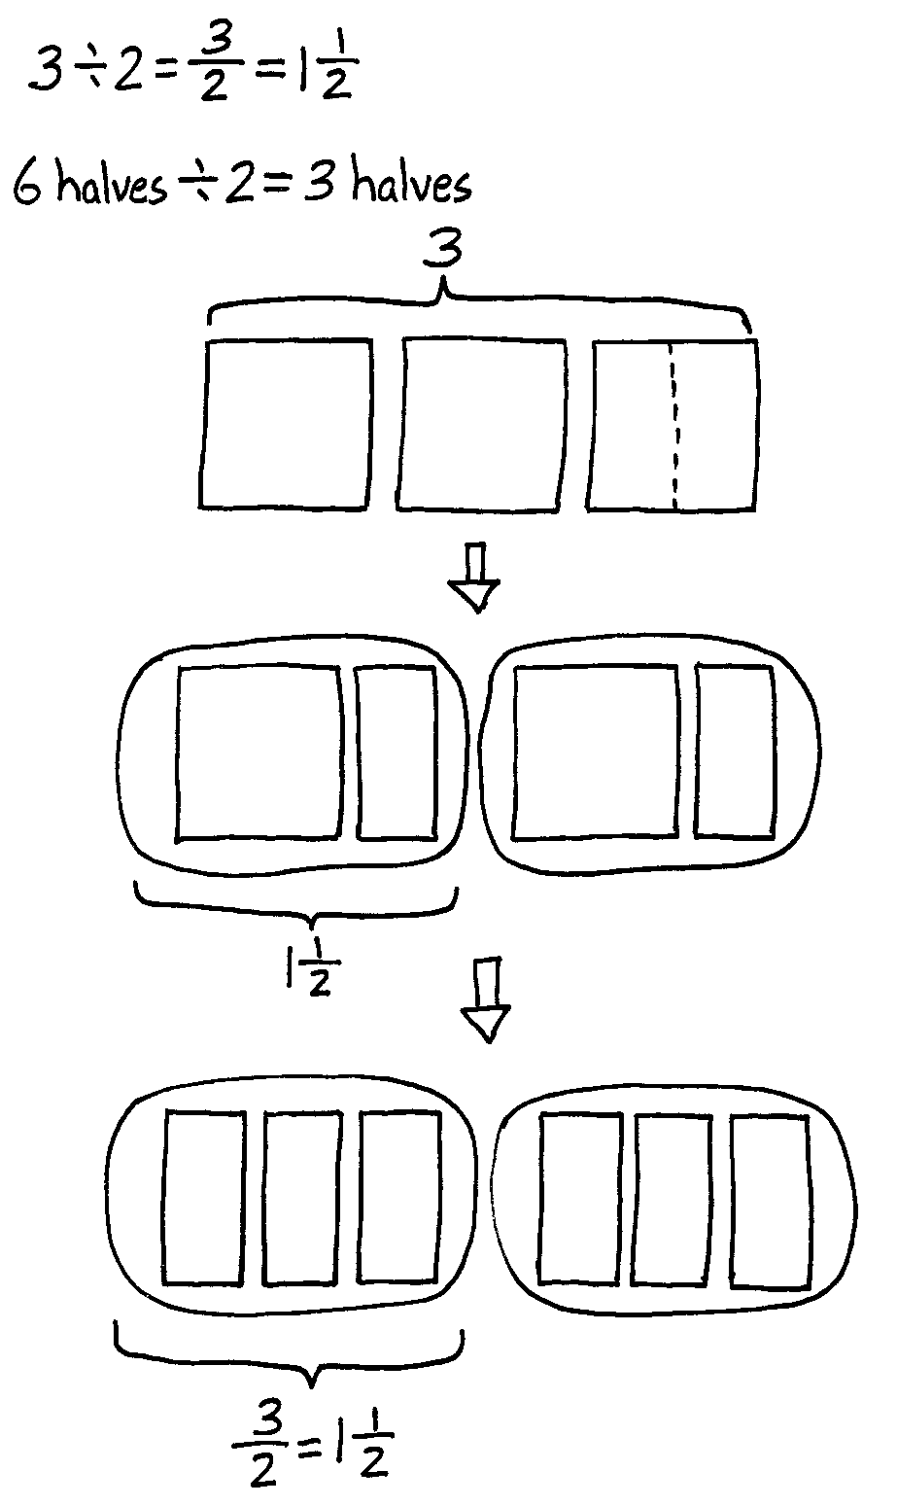
T: Now, let’s take 3 crackers and share them equally with 2 people. (Draw 3 squares on the board. Underneath the squares, draw 2 circles to represent the portion each person receives.) Turn and talk about how you can share these crackers. Use your materials to show your thinking.
S: I have 3 crackers, so I can give 1 whole cracker to both people. Then, I’ll just have to split the third cracker into halves and share it. Since there are 2 people, we could cut each cracker into 2 parts, and then share them equally that way.
T: Let’s record these ideas by drawing. We have 3 crackers. I heard someone say that there is enough for each person to receive a whole cracker. Draw a whole cracker in each circle.
S: (Draw.)
T: How many crackers remain?
S: 1 cracker.
T: What must we do with the remaining cracker if we want to continue sharing equally?
S: Divide it into 2 equal parts. Split it in half.
T: How many halves will each person receive?
S: 1 half.
T: Record that by drawing one-half of the cracker within each circle. How many crackers did each person receive?
S: 1 and $\frac{1}{2}$ crackers.
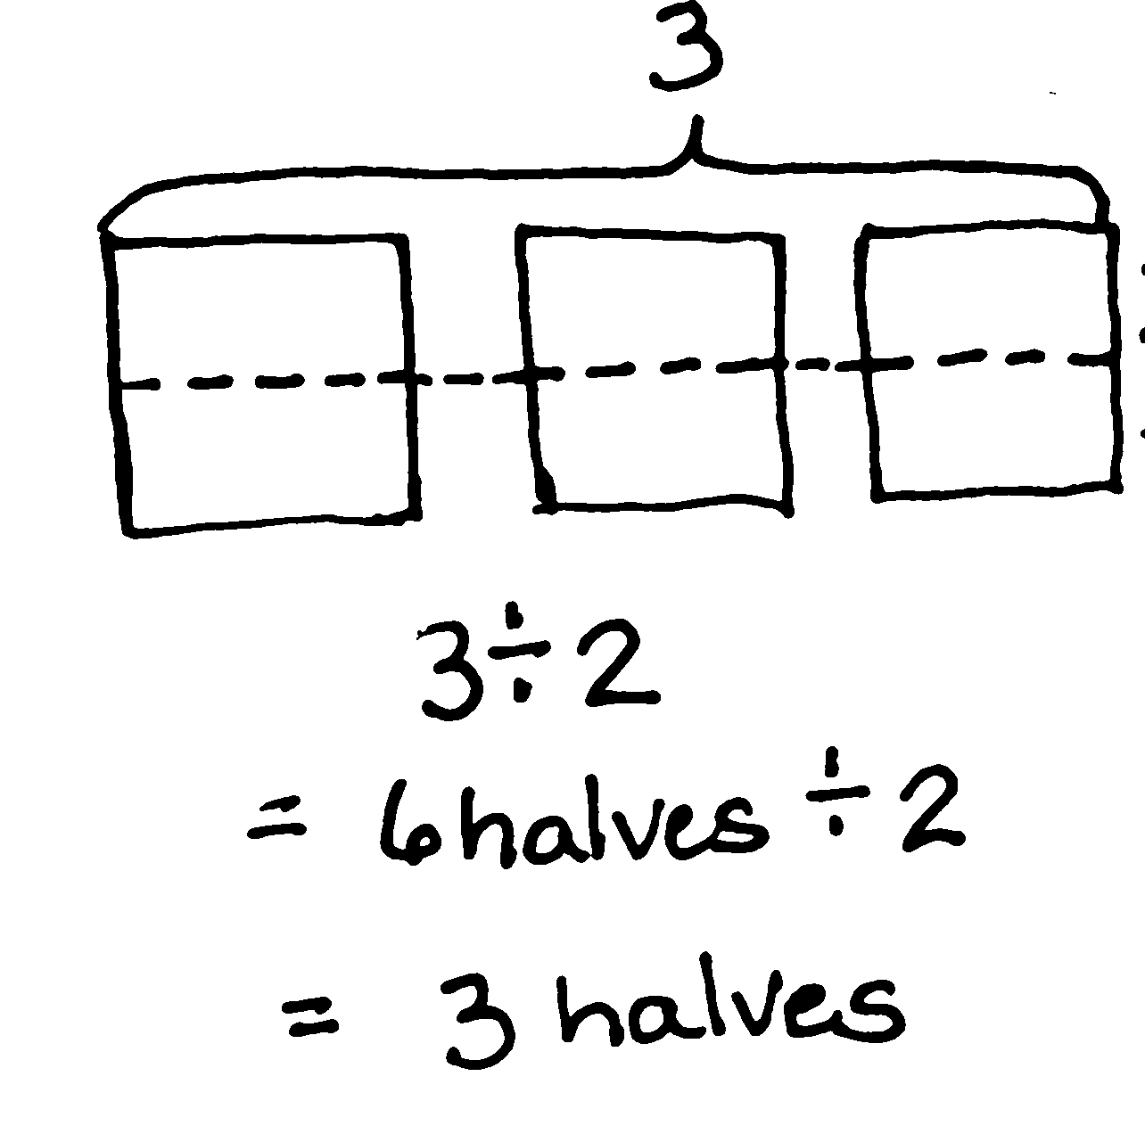
T: (Write 3 ÷ 2 = 1$\frac{1}{2}$ beneath the drawing.) How many halves are in 1 and 1 half?
S: 3 halves.
T: (Write $\frac{3}{2}$ next to the equation.) I noticed that some of you cut the crackers into 2 equal parts before you began sharing. Let’s draw that way of sharing. (Redraw 3 wholes. Divide them into halves horizontally.) How many halves were in 3 crackers?
S: 6 halves.
T: What’s 6 halves divided by 2? Draw it.
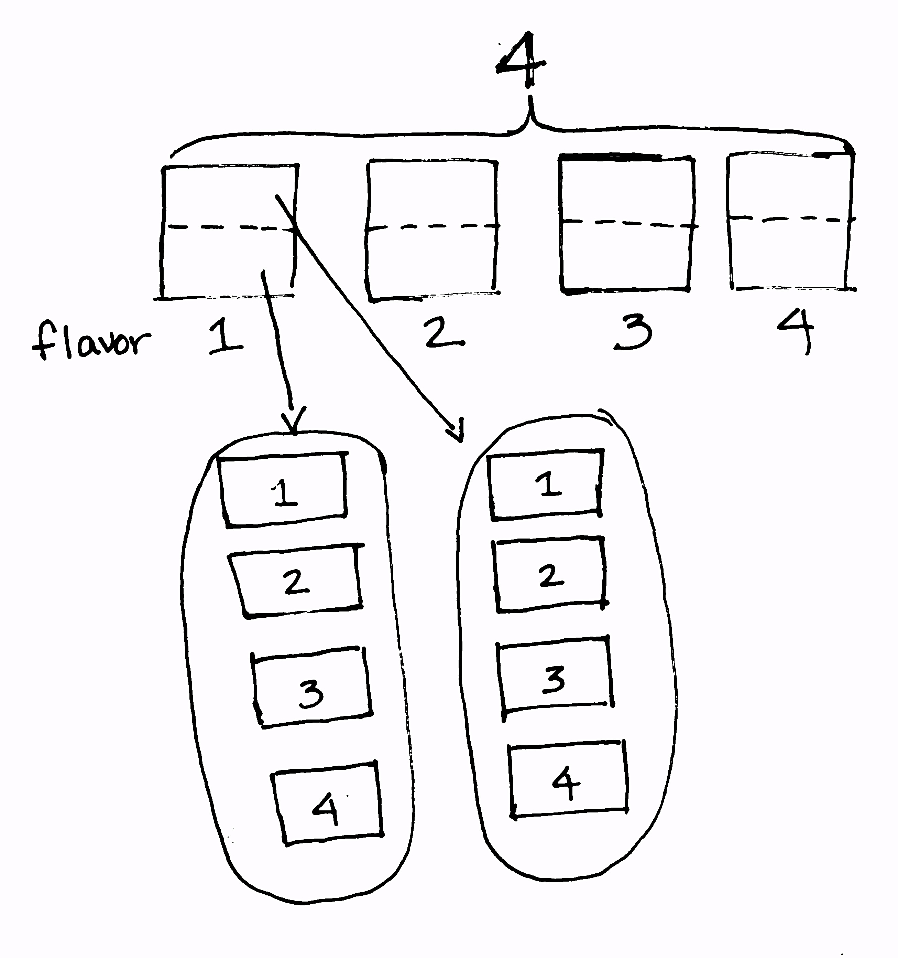
S: (Draw.) 3 halves.
Problem 3
4 ÷ 2
5 ÷ 2
T: Imagine 4 crackers shared with 2 people. How many would each person receive?
S: 2 crackers.
T: (Write 4 ÷ 2 = 2 on the board.) Let’s now imagine that all four crackers are different flavors, and both people would like to taste all of the flavors. How could we share the crackers equally to make that possible? Turn and talk.
S: To be sure everyone got a taste of all 4 crackers, we would need to split all of the crackers in half first, and then share.
T: How many halves would we have to share in all? How many would each person get?
S: 8 halves in all. Each person would receive 4 halves.
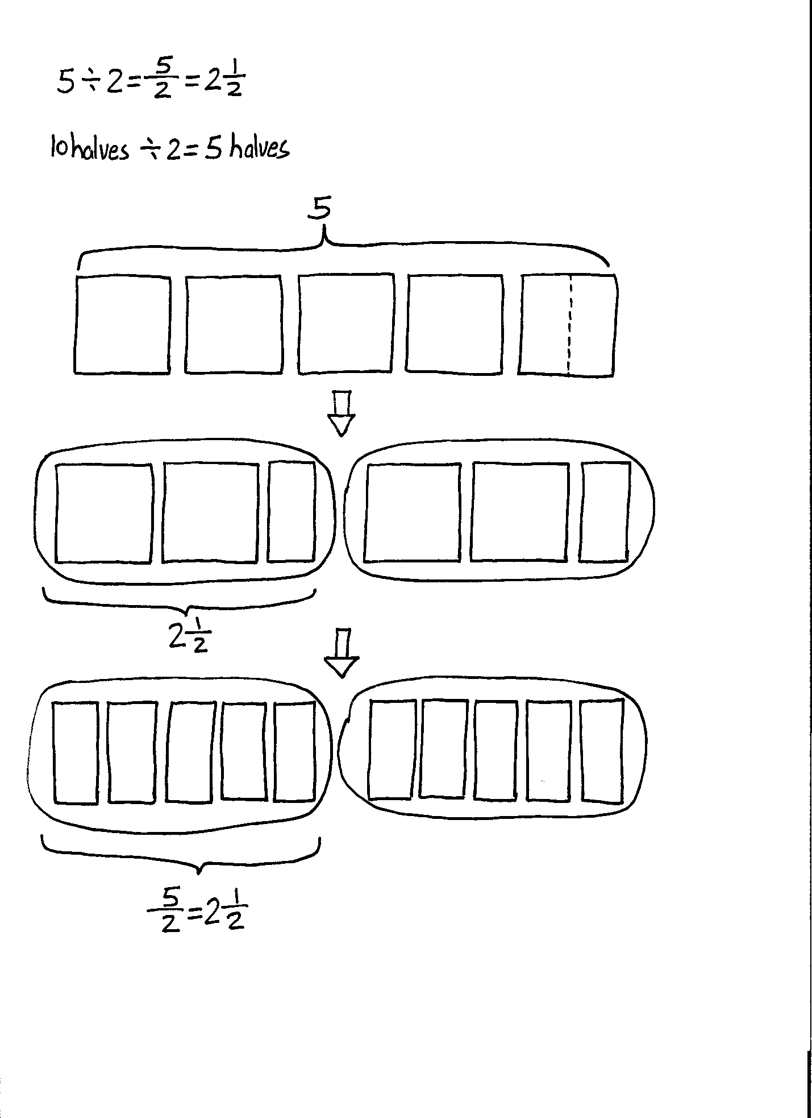
T: Let me record that. (Write 8 halves ÷ 2 = 4 halves.) Although the crackers were shared in units of one-half, what is the total amount of crackers each person receives?
S: 2 whole crackers.
Follow the sequence above to discuss 5 ÷ 2 using 5 crackers of the same flavor, followed by 5 differently flavored crackers. Discuss the two ways of sharing.
T: (Point to the division equations that have been recorded.) Look at all the division problems we just solved. Talk to your neighbor about the patterns you see in the quotients.
S: The numbers in the problems are the same as the numbers in the quotients. The division expressions can be written as fractions with the same digits. The numerators are the wholes that we shared. The denominators show how many equal parts we made. The numerators are like the dividends, and the denominators are like the divisors. Even the division symbol looks like a fraction. The dot on top could be a numerator, and the dot on the bottom could be a denominator.
T: Will this always be true? Let’s test a few. Since 1 divided by 4 equals 1 fourth, what is 1 divided by 5?
S: 1 fifth.
T: (Write 1 ÷ 5 = $\frac{1}{5}$.) What is 1 ÷ 7?
S: 1 seventh.
T: 3 divided by 7?
S: 3 sevenths.
T: Let’s try expressing fractions as division. Say a division expression that is equal to 3 eighths.
S: 3 divided by 8.
T: 3 tenths?
S: 3 divided by 10.
T: 3 hundredths?
S: 3 divided by 100.
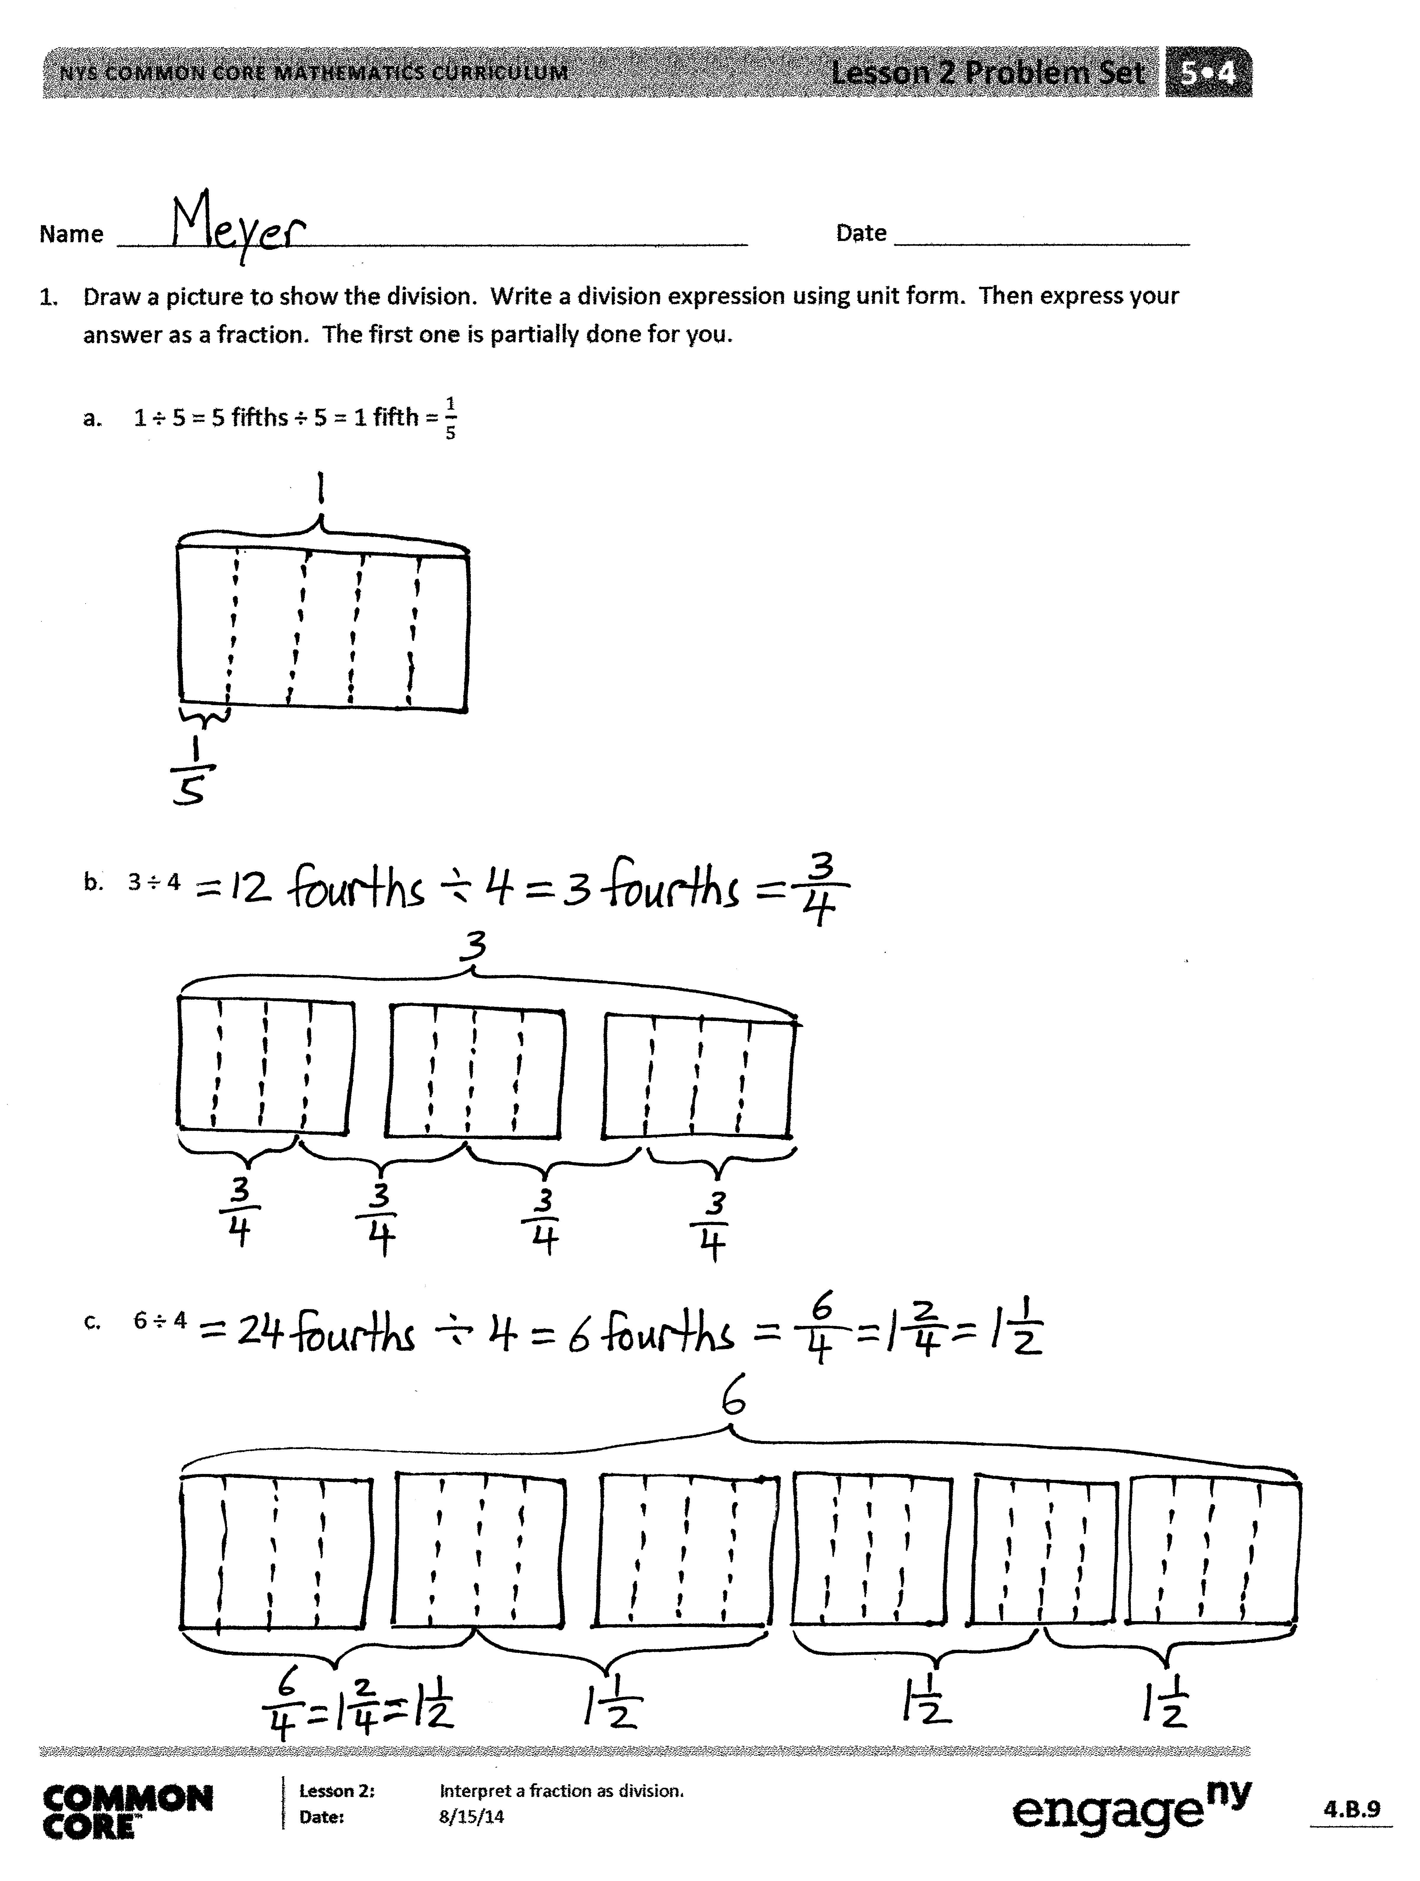
Problem Set (10 minutes)
Students should do their personal best to complete the Problem Set within the allotted 10 minutes. For some classes, it may be appropriate to modify the assignment by specifying which problems they work on first. Some problems do not specify a method for solving. Students should solve these problems using the RDW approach used for Application Problems.
Student Debrief (10 minutes)
Lesson Objective: Interpret a fraction as division.
The Student Debrief is intended to invite reflection and active processing of the total lesson experience.
Invite students to review their solutions for the Problem Set. They should check work by comparing answers with a partner before going over answers as a class. Look for misconceptions or misunderstandings that can be addressed in the Debrief. Guide students in a conversation to debrief the Problem Set and process the lesson.

You may choose to use any combination of the questions below to lead the discussion.
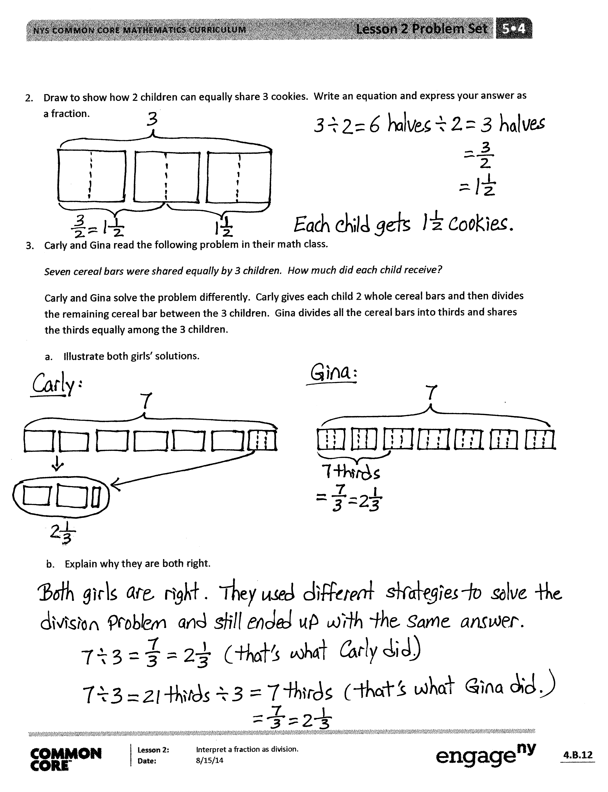
- What did you notice about Problems 4(a) and 4(b)? What were the wholes, or dividends, and what were the divisors?
- What was your strategy to solve Problem 1(c)?
- What pattern did you notice between 1(b) and 1(c)? What was the relationship between the size of the dividends and quotients?
- Discuss the division sentence for Problem 2. What number is the whole, and what number is the divisor? How is the division sentence different from 2 ÷ 3?
- Explain to your partner the two sharing approaches in Problem 3. (The first approach is to give each girl 2 wholes, and then partition the remaining bars. The second approach is to partition all 7 bars, 21 thirds, and share the thirds equally.) When might one approach be more appropriate? (If the cereal bars were different flavors, and each person wanted to try each flavor.)
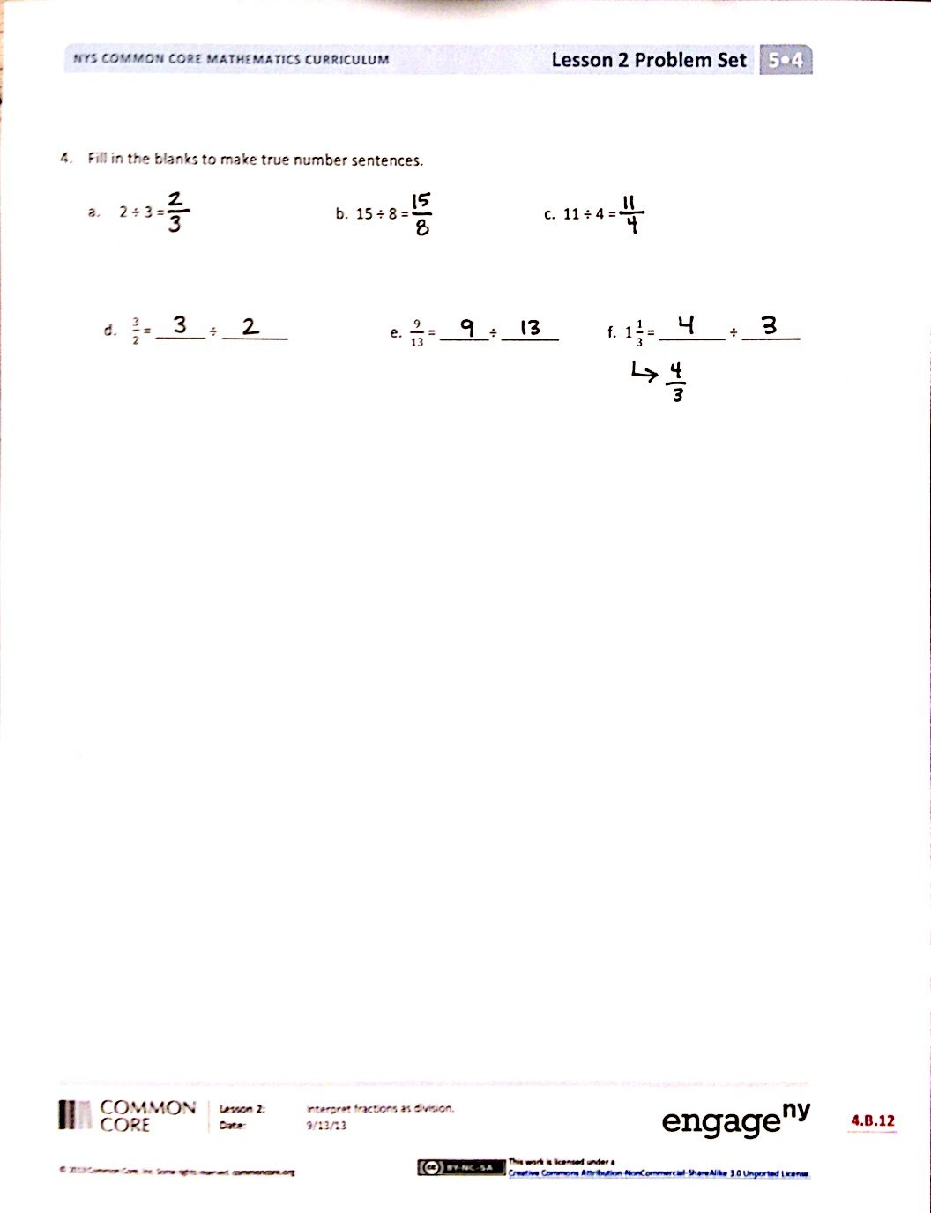
- True or false? Dividing by 2 is the same as multiplying by $\frac{1}{2}$. (If needed, revisit the fact that
3 ÷ 2 = $\frac{3}{2}$ = 3 × $\frac{1}{2}$.)
Exit Ticket (3 minutes)
After the Student Debrief, instruct students to complete the Exit Ticket. A review of their work will help you assess the students’ understanding of the concepts that were presented in the lesson today and plan more effectively for future lessons. You may read the questions aloud to the students.

Name Date
- Draw a picture to show the division. Write a division expression using unit form. Then, express your answer as a fraction. The first one is partially done for you.

- 1 ÷ 5 = 5 fifths ÷ 5 = 1 fifth = $\frac{1}{5}$

- 3 ÷ 4

- 6 ÷ 4

- Draw to show how 2 children can equally share 3 cookies. Write an equation, and express your answer as a fraction.

- Carly and Gina read the following problem in their math class.
Seven cereal bars were shared equally by 3 children. How much did each child receive?
Carly and Gina solve the problem differently. Carly gives each child 2 whole cereal bars, and then divides the remaining cereal bar between the 3 children. Gina divides all the cereal bars into thirds and shares the thirds equally among the 3 children.
- Illustrate both girls’ solutions.

- Explain why they are both right.

- Fill in the blanks to make true number sentences.

  - 2 ÷ 3 = b. 15 ÷ 8 = c. 11 ÷ 4 =

d. $\frac{3}{2}$ = ______ ÷ ______ e. $\frac{9}{13}$ = ______ ÷ ______ f. $1\frac{1}{3}$ = ______ ÷ ______

Name Date
- Draw a picture that shows the division expression. Then, write an equation and solve.

- 3 ÷ 9 b. 4 ÷ 3

- Fill in the blanks to make true number sentences.

- 21 ÷ 8 = b. $\frac{7}{4}$ = ______ ÷ ______ c. 4 ÷ 9 = d. $1\frac{2}{7}$ = ______ ÷ ______

Name Date
- Draw a picture to show the division. Express your answer as a fraction.

- 1 ÷ 4

- 3 ÷ 5

- 7 ÷ 4

- Using a picture, show how six people could share four sandwiches. Then, write an equation and solve.

- Fill in the blanks to make true number sentences.

- 2 ÷ 7 = b. 39 ÷ 5 = c. 13 ÷ 3 =

- $\frac{9}{5}$ = ______ ÷ ______ e. $\frac{19}{28}$ = ______ ÷ ______ f. $1\frac{3}{5}$ = ______ ÷ ______

